IACUC Training Exercise #3- 2015 (Single housing of mice)
The following exercise may be useful in stimulating discussion regarding compliance with PHS Policy and VA Handbook 1200.07. To facilitate discussion, pages 1-3 of the exercise may be distributed to the IACUC members prior to a meeting. After a few minutes of discussion about the exercise during the meeting, the remainder of the exercise may be distributed to provide ideas for the committee’s consideration.

Ann Marie, the Hometown VAMC-IACUC Manager, was checking her email on Monday morning and found a new ACORP had been submitted. The new ACORP file included an Appendix 9. She was well aware that Appendix 9 was used to document departures from the Guide that had been approved by the IACUC and were to be included in the semiannual report to the Institutional Official. Ann Marie also knew that some deviations from the Guide were not departures and should not be included in Appendix 9. Figuring out deviations versus departures was tricky so Ann Marie always kept her VA Deviations and Departures flowchart close at hand (see page 2); she found going through the following logic helped her sort things out:
- Does the Guide describe the standard as a “may” statement? If so, no departure has occurred because “may” statements are suggestions. Appendix 9 is not needed.
- Does the Guide in relation to a “must” or “should” statement list an exception that permits deviation? If so, no departure has occurred. Appendix 9 is not needed.
- Does the “should” statement meet the criteria for a well-established performance standard? If so, no departure has occurred. Appendix 9 is not needed.
She noticed the ACORP’s Appendix 9 was related to single housing. Ann Marie spent some time reviewing the Guide looking for statements related to single housing and comparing the applicable statements to the VA Deviations and Departures flowchart before deciding that she had spotted a few problems with the Appendix 9.
What problems do you think Ann Marie found and was an Appendix 9 actually needed?

VA Deviations and Departures Flowchart

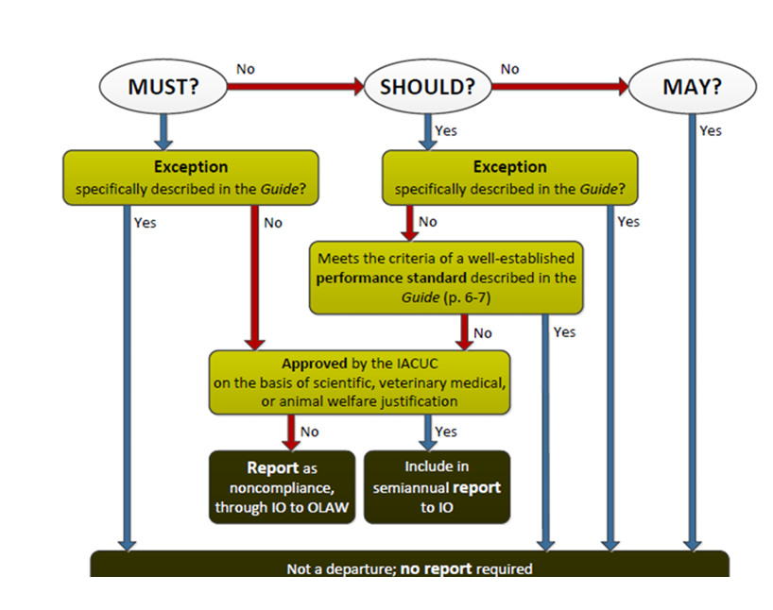

The Appendix 9 of the new ACORP that Ann Marie received is shown below; please note this Appendix 9 (verbatim) was submitted for JIT secondary veterinary review.
ACORP Appendix 9
DEPARTURES FROM "MUST" AND "SHOULD" STANDARDS IN THE GUIDE (2011)
VERSION 4
See ACORP App. 9 Instructions, for more detailed explanations of the information requested.

For each IACUC-approved "departure" of this protocol from a "Must" or "Should" standard in the Guide, provide the following information. (Consult the IACUC or the Attending Veterinarian for help in determining whether any "departures" are involved.):

Copy the lines below for each departure.
Briefly summarize the "Must" or "Should" standard, and provide the number(s) of the page(s) on which it appears in the Guide.

►Social animals should be housed in pairs or groups. Chapter 3, Page 51.

Describe the specific alternate standard(s) that will be met on this protocol and how they will be monitored.

►Mice will be single housed: males after breeding. any animal fighting, those in nesting studies, those in running wheel studies.

Provide the scientific, veterinary medical or animal welfare considerations that justify this departure

►After having been single housed, male mice routinely fight when social housing is attempted. Single housing is required during running wheel studies because data is collected from a single animal; the instrument cannot distinguish between animals. Nesting study mice are only singly to score next building; they are housed very briefly (less than 24 h). Nesting animals may be rehoused with cagemates when testing is completed.

The analysis of the ACORP’s Appendix 9 is shown below in red font.
ACORP Appendix 9
DEPARTURES FROM "MUST" AND "SHOULD" STANDARDS IN THE GUIDE (2011)
VERSION 4
See ACORP App. 9 Instructions, for more detailed explanations of the information requested.

For each IACUC-approved "departure" of this protocol from a "Must" or "Should" standard in the Guide, provide the following information. (Consult the IACUC or the Attending Veterinarian for help in determining whether any "departures" are involved.):

Copy the lines below for each departure.
Briefly summarize the "Must" or "Should" standard, and provide the number(s) of the page(s) on which it appears in the Guide.

►Social animals should be housed in pairs or groups. Chapter 3, Page 51.

The quote is incomplete. The full sentence is: “Social animals should be housed in stable pairs or groups of compatible individuals unless they must be housed alone for experimental reasons or because of social incompatibility (see also section on Behavioral and Social Management).”

Describe the specific alternate standard(s) that will be met on this protocol and how they will be monitored.

►Mice will be single housed: males after breeding. any animal fighting, those in nesting studies, those in running wheel studies.

The rationale shown above is consistent with a deviation from a “should” statement according to a specifically established exception in the Guide (experimental reasons and social incompatibility).

Provide the scientific, veterinary medical or animal welfare considerations that justify this departure

►After having been single housed, male mice routinely fight when social housing is attempted. Single housing is required during running wheel studies because data is collected from a single animal; the instrument cannot distinguish between animals. Nesting study mice are only singly to score next building; they are housed very briefly (less than 24 h). Nesting animals may be rehoused with cagemates when testing is completed.

The investigator has provided justification for why it is necessary to house the mice singly. The reasons given are social incompatibility (fighting males) and experimental requirements (running wheels and nest building). The IACUC approved the investigator’s justification. Exceptions are not departures from the Guide and have no reporting requirements. Appendix 9 is not needed and should be deleted from the ACORP.

____________________________________________________________________________________The next page provides a list of specifically established exceptions to the Guide; please note the list is not necessarily all inclusive.

Specifically Established Exceptions to Guide Standards
- “Prolonged restraint, including chairing of nonhuman primates, should be avoided unless it is essential for achieving research objectives and is specifically approved by the IACUC (NRC 2003b).” (pg. 29)

- The use of non-pharmaceutical-grade chemicals and other substances should be described and justified in the animal use protocol and be approved by the IACUC (Wolff et a,. 2003); for example, the use of non-pharmaceutical grade chemical or substance may be necessary to meet the scientific goals of a project or when a veterinary or human pharmaceutical-grade product is unavailable.” (pg. 31)
- “Radios, alarms, and other sound generators should not be used in animal rooms, unless they are part of an approved protocol or enrichment program.” (pg. 50)
- “Social animals should be housed in stable pairs or groups of compatible individuals unless they must be housed alone for experimental reasons or because of social incompatibility.” (pg. 51)
- “If necessary to house animals singly – for example, when justified for experimental purposes, for provision of veterinary care, or for incompatible animals – this arrangement should be for the shortest duration possible.” (pg. 60)
- “Appropriate social interactions among members of the same species are essential to normal development and well-being….single housing of social species should be the exception and justified based on experimental requirements or veterinary related concerns about animal well-being.” (pg. 64)
- “Unless an exception is specifically justified as an essential component of the research protocol and approved by the IACUC, aseptic surgery should be conducted in dedicated facilities or spaces.” (pg. 116)
- “Unless a deviation is justified for scientific or medical reasons, methods should be consistent with the AVMA Guidelines on Euthanasia (AVMA 2007 or later editions).” (pg. 123)

