Department of Veterans Affairs

Office of Information & Technology

Field Operations



Universal Serial Bus (USB)

Flash Drive

User Guide

2.0

March 9, 2007

* The USB Flash Drive User Guide is a supplement to Directive 6601

Table of Contents
Section 1 Introduction 3
1.1 Background 3
1.2 Summary 3
Section 2 Responsibilities 3
2.1 Veterans Affairs Employees 3
2.2 Facility Information Security Officers 3
Section 3 Procedures 4
3.1 Validate Legitimate Need for USBFD’s 4
3.2 Establish Straightforward Acquisition Approval and Procurement Process 4
3.3 Standardize the Issuance of USBFD’s and other IT Equipment 5
3.4 Sanitization of non-FIPS compliant USBFD’s 5
Section 4 USBFD Usage Instructions 6
4.1 Meganet Instructions 6
4.1.1 Meganet VME USB Drive UD 6
4.1.2 Meganet VME BioDrive XD/UD 10
4.2 Kanguru Instructions 15
Section 5 Frequently Asked Questions 26
5.1 Meganet FAQs 26
5.2 Kanguru FAQs 27
Section 6 Web Links 28
Section 7 References 28
Department of Veterans Affairs 39
Office of Information and Technology 39

Section 1 Introduction

1.1 Background
In response to security vulnerabilities exacerbated by the transit of Protected Information (PI) on portable, high capacity Universal Serial Bus Flash Drives (USBFD’s), the Department of Veterans Affairs (VA) will minimize its risk posture by ensuring all government furnished USBFD’s meet the National Institute of Standards and Technology (NIST) Federal Information Processing Standards (FIPS) 140-2 standard for protecting sensitive information. The USB Flash Drive User Guide has been developed as a supplement to VA Directive 6601, Removable Storage Media. This document will provide operational guidance to the VA on the procurement, tracking, and disposal of USBFDs, as well as provide instructions and frequently asked questions on the use of each of the approved USBFDs.

1.2 Summary
Compliance with the FIPS 140-2 standard will require the wholesale replacement of USBFD’s at all VA facilities. This document outlines the processes that will be undertaken to accomplish the following:

- Validate the legitimate need for USBFD’s by VA employees;
- Establish a straightforward acquisition approval and procurement process for new USBFD’s;
- Standardize the issuance of USBFD’s and other Information Technology equipment; and
- Create processes for the sanitization of non-FIPS compliant USBFD’s.

It is mandatory that all steps be accomplished no later than close of business April 18, 2007.

Section 2 Responsibilities

2.1 Veterans Affairs Employees
Veterans Affairs (VA) employees are responsible for the following:
- Transfer of ALL data on existing USBFD’s to a secure storage location (e.g. network storage account/drive) prior to turning in existing USBFD’s; and (Data should not be transferred to non-GFE)
- Turn in of all government furnished USBFD’s to the FISO.

2.2 Facility Information Security Officers
Facility Information Security Officers (FISOs) are responsible for the following:
- Creating a secure collection process for existing, government furnished USBFD’s;
- Verifying that all data has been deleted from USBFD’s;
- Prompt inventory and shipment of these USBFD’s to the VA’s media destruction contractor; and
- Confirmation of receipt of USBFD’s from the media destruction contractor.

Section 3 Procedures

3.1 Validate Legitimate Need for USBFD’s
The risk of exposure of PI can be best mitigated by first ensuring that only those VA employees whose positions require the transit of information on USBFD’s are granted such a device. These decisions will be made by management in the Administrations, Program and Staff Offices.

Employees wishing to check out a USBFD will be required to complete a USB Flash Drive Request Memo (Attachment B) and obtain approval from their immediate supervisor. Management will compile these requests and enter the information into the USBFD Request Spreadsheet (Attachment C).

If there is a need to store, transport and utilize sensitive information outside a VA protected environment, then an additional approval step is required. The employee must complete a request to take VA information offsite (Attachment D) and seek approval from the Director of the local VA facility or his/her designee.

Once completed, these memoranda must be signed by the Facility CIO and FISO. Local facility management will submit the justification forms and the completed spreadsheet to the Facility ISO (FISO). The FISO will review the requests, provide concurrence and forward the spreadsheet to the local IT Operations Service for action. The FISO will keep all request memoranda on file.

3.2 Establish Straightforward Acquisition Approval and Procurement Process
USBFD’s are considered IT items for the purpose of acquisition, operations and maintenance. Therefore, local IT Operations Services will be responsible for the procurement, issuance, tracking and recovery of USBFD’s, much in the same way as laptop computers and cell phones are managed.

Upon receipt of the USBFD spreadsheet from the FISO, IT Operations Service will initiate an IT Acquisition Approval System (ITAA) request for the new equipment. Under the “New or Replacement” drop-down menu, the entry entitled “100% VA APPROVED SEWP USBFD FIPS COMPLIANT” must be chosen.

Acquisition approval will be delegated to the OI&T Regional Director. The SEWP III approved list of FIPS 140-2 compliant USBFD manufacturers has been added to the “Select Agency” drop-down menu on the SEWP Product Search web site at http://sewp.nasa.gov/cgi-bin/socs.pl?ACTION=RFI. There are presently only two USBFD manufacturers available: Meganet and Kanguru Solutions. Only 1 gigabyte and 2 gigabyte drive types are on the approved list.

Facilities should use existing incidental funds to cover the costs of the USBFD’s. Facility and Network CIO’s should coordinate with their respective Regional Director should the need for additional funds arise. When placing orders, Facility IT Operations staff should use BOC 2623 for all USBFD’s.

3.3 Standardize the Issuance of USBFD’s and other IT Equipment
A standardized OI&T Equipment Check Out Sheet has been developed and approved for use by all VA facilities (Attachment D). The issuance of all government furnished equipment (GFE) from IT Operations Services will be recorded on this new document. This includes, but is not limited to, the following items commonly checked-out for use:
- Laptop Computers
- Removable Media (including all USBFD’s)
- Broadband Cards
- Mobile Phones
- Pagers
- Desktop Computers

With regard to the issuance of USBFD’s, Facility IT Operations Services are responsible for the following:
- Testing USBFD’s for functionality.
- Configuring USBFD’s to ensure all authentication and encryption features are set appropriately. This includes steps to register the USBFD and obtain a serial number. The serial number should be recorded on the Equipment Check Out Sheet and be shared with the local Acquisition and Material Management or Logistics Service to ensure appropriate inventory accountability (e.g. AEMS/MERS, EIL/CMR).
- Demonstrating appropriate USBFD use to the employee, including the appropriate transfer of files to and from the USBFD.
- Obtaining employee signature on the Equipment Check Out Sheet. Proxies are not acceptable. A photocopy of the Check Out Sheet should be provided to the employee once all information is obtained and all signatures are recorded.
- Maintaining a file of all Equipment Check Out Sheets issued in a secure location under lock and key (e.g. lockable file cabinet).

All existing FIPS 140-2 compliant USBFD’s shall be returned, inspected and reissued using the new IT Equipment Check Out Sheet.

3.4 Sanitization of non-FIPS compliant USBFD’s

In addition to the issuance of FIPS compliant USBFD’s, new software tools will soon prohibit the use of non-FIPS compliant USBFD’s. FISOs will accept existing, government furnished USBFD’s and will utilize the existing VA media destruction contract to ensure all legacy USBFD’s are disposed of in a secure manner.

Section 4 USBFD Usage Instructions

4.1 Meganet Instructions

4.1.1 Meganet VME USB Drive UD

IMPORTANT NOTICE

This Application will only work on the Non-Biometric VME BioDrive UD.

If you have the Biometric VME BioDrive XD, Please download the VME Commander XD from www.meganet.com/download

If you just downloaded this application from the web site, please extract ALL files to the BioDrive root directory. It will NOT work from your computer's hard drive. DO NOT DELETE THE "VME Commander" DIRECTORY OR ANY OF ITS FILES OR THE APPLICATION WON'T WORK.

Activation & Unlock: (Activation and unlock is a one time process and must be done by the Facility IT Operations Services)
1. Double Click on the "VME Commander UD.exe" application icon.

2. In the Activation Window enter your 12 Letters Activation Code.
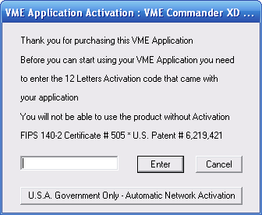
3. Once successfully activated, the registration windows will pop up.
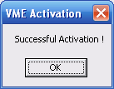
4. Fill in all 10 fields and click on "Internet Activation"
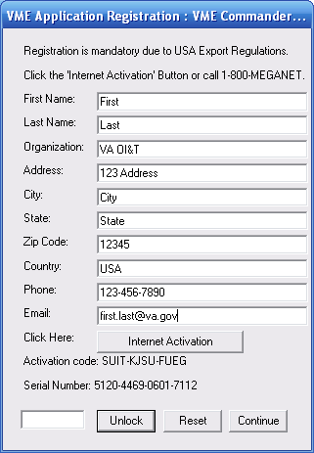

5. You may need to open the port for the HIPS Proventia and/or the WAN firewall. Meganet can also activate the device and can be contacted at 1-213-620-1666.

Meganet will need the activation code and serial number and they will provide you with an eight (8) digit unlock code. The 8 digit activation code must be typed into the lower activation box and click “Unlock.”
6. Click OK

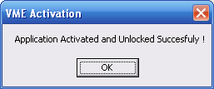

7. Click OK
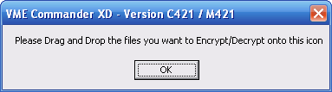

8. The device is ready to use.

Obtaining USB ID:

* This step should be done by the Facility IT Operations Services to obtain the USB ID for Inventory Tracking*

- With the Meganet device connected to the USB, copy the .dll’s and the USBID.exe to the hard drive of the system or copy the “VME Commander” folder to the hard drive and run the USBid.exe found inside the folder.
- To get the ID of the USB drive select “Get USB ID” button.

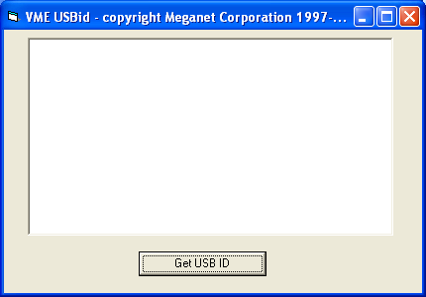

- The ID of the device will be displayed. Copy this ID onto the spreadsheet.

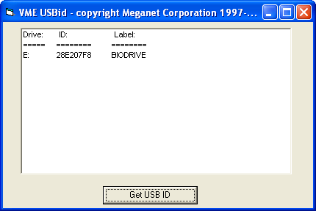

Encryption Procedure:
- To encrypt files, folders or even a whole drives (Drive C Exempted), drag and drop the files, directories or drives, or any combination thereof holding down the "Control" button.
- Drop the files, folders or whole drives on the "VME Commander UD.exe" Icon.
14. The application will prompt you for a password to use for the encryption session and any password will be accepted as long as the user remembers it.
15. All encrypted files will receive the ".vme" extension in addition to any existing extension. “.vme” symbolizes to the application that those files are encrypted.
16. All encrypted files will be placed automatically on the USB Drive. These files can then be copied to another drive, a CD, another media, disk, or even a network location if needed.
17. At the end of the process, the application will tell you how many files were encrypted. Any open files, read only files, hidden files, system files, files in use etc. will be skipped and an error message will inform you of which files were skipped.

Decryption Procedure:
18. Drag and drop any encrypted files with the ".vme" extension, directories including ".vme" files, or even WHOLE DRIVE/S (Drive C Excluded).
19. The application will ask you for the password. As long as that password matches the other files it will keep on decrypting them. If a file in the batch is encrypted with a different password, the application will show the file name and ask you to enter the correct password for that file. Decryption then will continue with the new password. To prevent confusion, use the same password for all files in a specific fold.

Note: The best approach so you won't have to remember multiple passwords for multiple files in the same directory is to choose one single password per directory/drive. Choose passwords that are hard to guess but easy for you to remember.

20. All decrypted files will get their original extension back and be placed automatically on the USB Drive.
21. Files can be copied to another drive, a CD, other media, disk, or even a network location if needed.

22. At the end of the process, the application will tell you how many files were decrypted. Any open files, read only files, hidden files, system files, files in use etc. will be skipped and an error message will inform you of which files were skipped.

Meganet VME BioDrive XD/UD

IMPORTANT NOTICE

This Application will only work on the Biometric VME BioDrive XD.

If you have the non-Biometric VME BioDrive UD, download the VME Commander UD from www.meganet.com/download

If you just downloaded this application from the web site, please extract ALL files to the BioDrive root directory. It will NOT work from your computer's hard drive. DO NOT DELETE THE "VME Commander" DIRECTORY OR ANY OF ITS FILES OR THE APPLICATION WON'T WORK.
________________________________________________________________________

Activation & Unlock: (Activation and unlock is a one time process and must be done by the Facility IT Operations Services)
1. Double Click on the "VME Commander UD.exe" application icon.

2. In the Activation Window enter your 12 Letters Activation Code.
3. Once successfully activated, the registration windows will pop up.
4. Fill in all 10 fields and click on "Internet Activation"

5. You may need to open the port for the HIPS Proventia and/or the WAN firewall. Meganet can also activate the device and can be contacted at 1-213-620-1666.

Meganet will need the activation code and serial number and they will provide you with an eight (8) digit unlock code. The 8 digit activation code must be typed into the lower activation box and click “Unlock.”
6. Click OK

7. Click OK

8. The device is ready to use.

Registering Fingerprints:

Note: Administrators of the devices will be necessary to enroll users and access the data on the devices if necessary. When selecting administrators, consideration should be given to cross coverage in the event one administrator is out, retires, etc.

9. Insert device into any available USB Port.
10. As the device powers on, it will read 'VME BioDrive’ and will then notify you that you are in 'Admin Setup' mode and that you need to 'Enroll 2 Fingers'.
11. Click the button to begin.
12. The device will notify you that you are registering 'Admin Finger 1'.
13. When prompted, place and lift your finger. (Do not lift until LCD displays ‘Lift Finger’.) You will need to do this a minimum of three times.
14. The LCD will indicate if it is a good finger placement or not. Experiment with pushing on the sensor with varying amounts of pressure until you find what works best.

Be aware of finger placement as shown below:

When ‘Admin Finger 1’ is accepted, it will notify you with 'Finger 1 Accepted'.

Note: While a fingerprint image is being acquired, it is best that you keep your finger in the same position on the sensor-- without movement. If enrollment is not successful with the first 3 fingerprint images, the device will ask you to “Record 3 More". If after this next set you are still having difficulty, make sure to adjust your finger so that the very center of your fingerprint is in the middle of the sensor. This will yield the most favorable results.

15. After Finger 1 is accepted, the device will notify you to enroll 'Admin Finger 2'
16. Repeat the process above to register the finger of the second admin. When 'Admin Finger 2' is accepted, the device will notify you with 'Setup Complete'. If you do not want a second admin you can use a second finger of the first admin.
17. The LCD will then read 'Device Ready'.
18. You may start reading and writing data to and from the device.

Obtaining USB ID:
* This step should be done by the Facility IT Operations Services to obtain the USB ID for Inventory Tracking*

- With the Meganet device connected to the USB, copy the .dll’s and the USBid.exe to the hard drive of the system or copy the “VME Commander” folder to the hard drive and run the USBid.exe.
- To get the ID of the USB drive select “Get USB ID” button.

- The ID of the device will be displayed. Copy this ID onto the spreadsheet.

Encryption Procedure:
22. To encrypt files, folders or even whole drives (Drive C Exempted) drag and drop the files, directories or drives, or any combination thereof holding down the "Control" button.
23. Drop them on the "VME Commander UD.exe" Icon.
24. The application will not prompt you for a password. Your fingerprint together with a built-in 256 bit AES key will do it for you automatically.
25. All encrypted files will receive the ".vme" extension in addition to any existing extension. The “vme.” extension symbolizes to the application that those files are encrypted.
26. All encrypted files will be placed automatically on the USB Drive. These files can then be copied to another drive, a CD, another media, disk, or even a network location if needed.
27. At the end of the process, the application will tell you how many files were encrypted. Any open files, read only files, hidden files, system files, files in use etc. will be skipped and an error message will inform you of which files were skipped.

Decryption Procedure:
28. Drag and drop any encrypted files with the ".vme" extension, directories including ".vme" files, or even WHOLE DRIVE/S (Drive C Excluded).
29. The application will not prompt you for a password. Your fingerprint together with a built-in 256 bit AES key will do it for you automatically.
30. All decrypted files will get their original extension back and be placed automatically on the USB Drive.
31. Files can be copied to another drive, a CD, other media, disk, or even a network location if needed.
32. At the end of the process, the application will tell you how many files were decrypted. Any open files, read only files, hidden files, system files, files in use etc. will be skipped and an error message will inform you of which files were skipped.

4.2 Kanguru Instructions
Notes:
- The minimum software version required for the Kanguru drive must have software version 1.5.5 which must be download from http://www.kanguru.com/tech_support/prod_tech.asp?prodid=71&r=usb.
- The first time the device is plugged in to any machine, the user must be an administrator. After that, the device does not require administrative privileges.
- An administrator to the machine must install and setup the device.

Kanguru System Requirements:
- Recommended Pentium III or higher or other compatible machines.
- Recommended RAM of at least 128 MB or higher.
- Operating System: Microsoft Windows 98SE / ME / 2000 / XP.
Setup: (Must be done by the Facility IT Operations Services)

1. Open USB drive and verify you have a minimum of v1.0.5.5 and then open that folder.
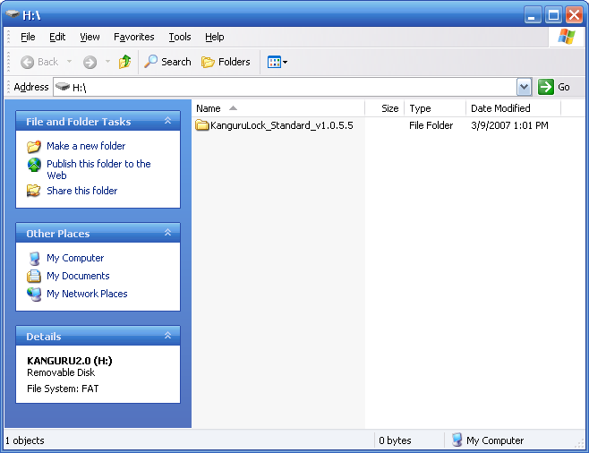
2. Click KanguruLock_setup.exe
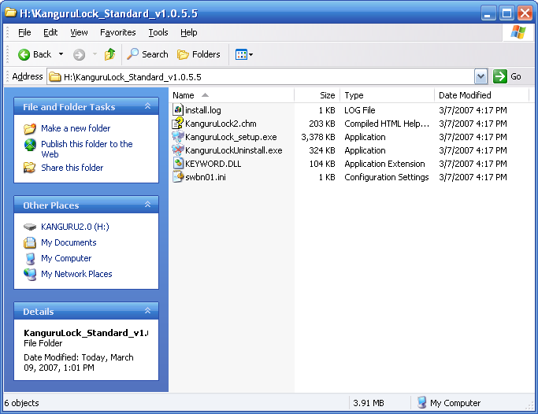

3. Check the box “Format as NTFS” and then OK
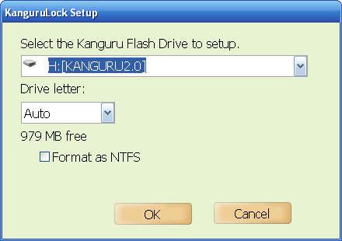

4. Click OK
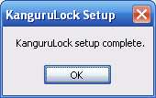
5. You will see the following screen:
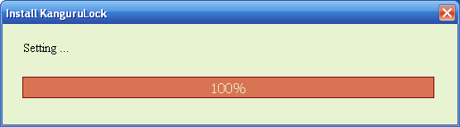

6. Click Yes
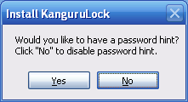

7. You will see the following screen: (Don’t remove your flash drive!)
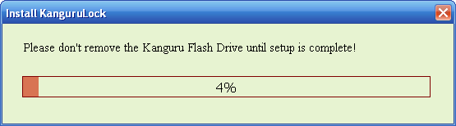
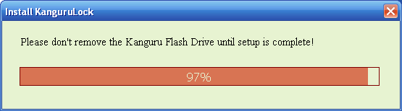

8. Click OK
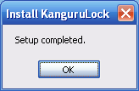

9. Click “Mount”
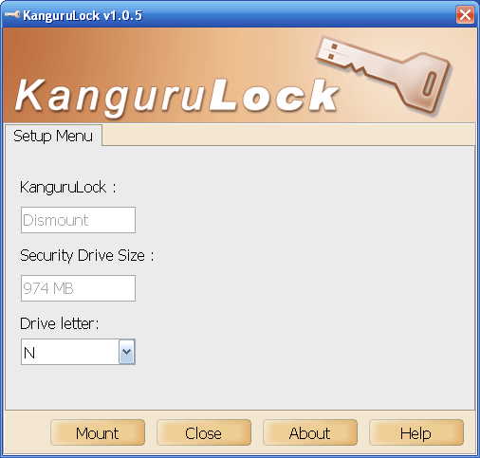

10. Enter the default password “kanguruAES” without quotes and click OK
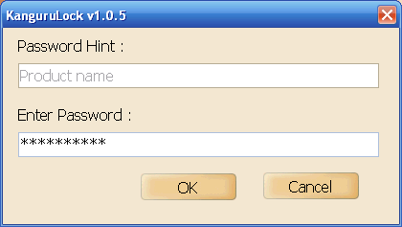

11. Click OK
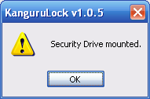
12. You now have a “Change Password” and “Status” tab, click the “Change Password” tab.
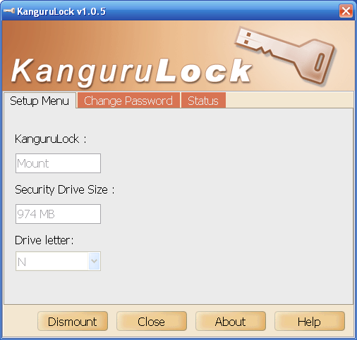

13. Enter the old password. Have the user available to enter a new password and a password hint (do not use any part of the password as your hint). The password must be from 8 – 31 characters in length and include at least one upper case and one lower case letter.

14. Click OK
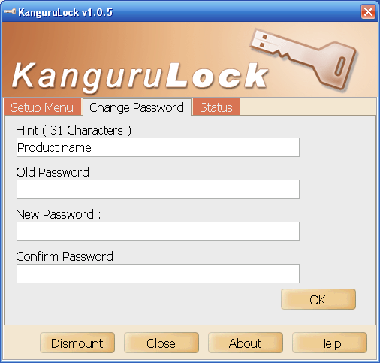

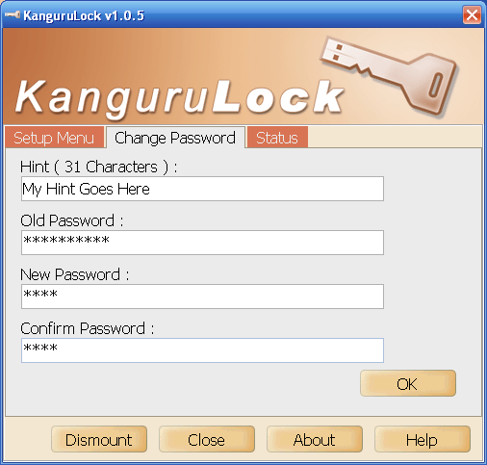

15. If you do not meet the password requirements you will receive this message.
Repeat the previous step to create a new password.
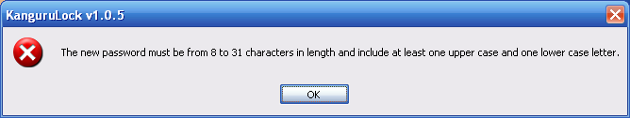

16. Click Yes
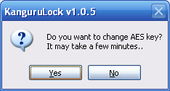

You will see a series of screen like the following:
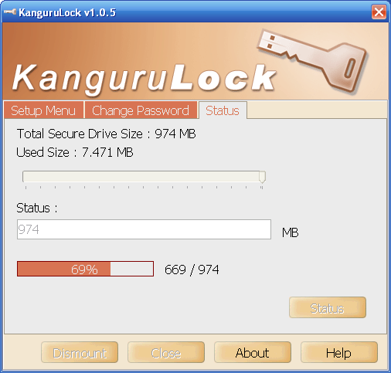

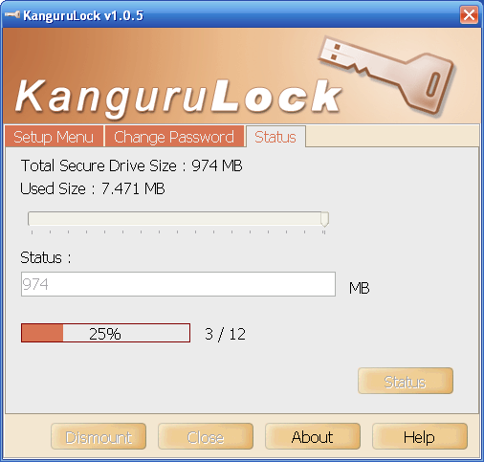
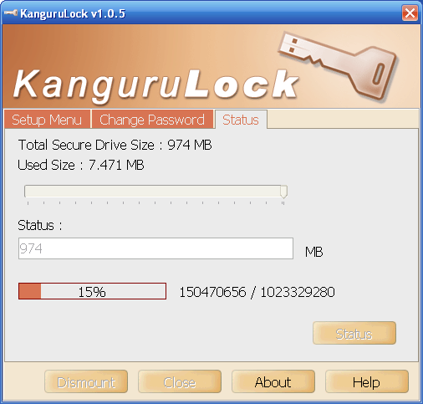

17. Click OK
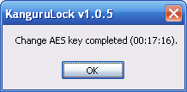

- Once you have given the drive to the user and need to setup another drive you will have to run “KanguruLockUninstall.exe” once the new drive is inserted. You can then proceed to the beginning.

19. If you do not run the “KanguruLockUninstall.exe” you will receive this message.
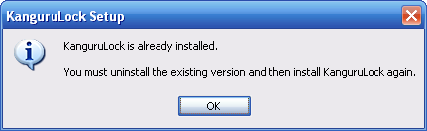

Mount Security Drive:
Follow these steps to mount the secure drive manually:
- Run the KanguruLock.exe program located on your KanguruMicro Drive.
- Click on the Mount button and enter the correct password 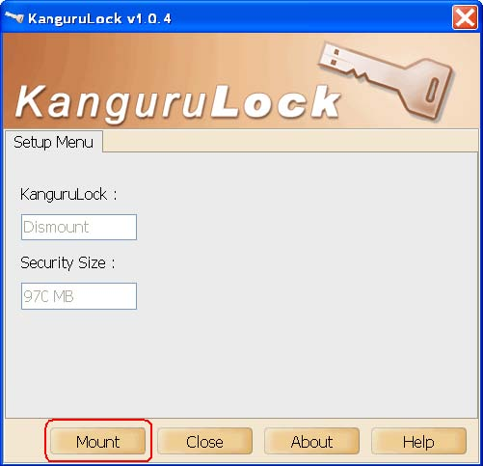
- Click OK when the dialog box states Security Drive mounted.
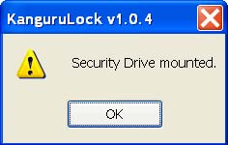

- You can manually remove the security drive by clicking on the Dismount button.

Change Password:
The new password must be from 8 to 31 characters in length and include at least one upper case and one lower case.
24. Click on the Change Password tab to reset the password.
25. Enter the old password then enter new password twice to confirm it.
26. Click OK to set the new password.
27. After changing the password, the system will ask you if you want to change AES key.
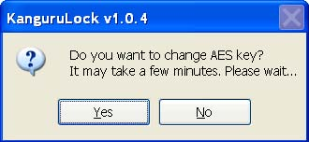
- Click Yes to change the AES key, but it may take a few minutes. Or click No to skip it. You can see the status of changing the AES key.
- Click OK when the dialog box states Change AES key completed.
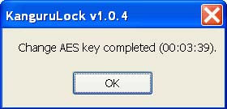

Remove the Security Drive:

When the secure portion of you KanguruMicro Drive is mounted, it will appear as a hard disk labeled Security.
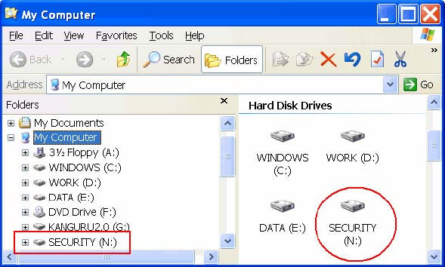
The drive can be manually removed from the system if you only want the public portion of your drive to be accessed. To do so,
30. Open KanguruLock and click on the Dismount button.
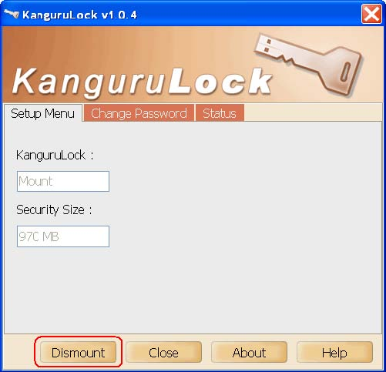
The Security drive will then be removed from your system.
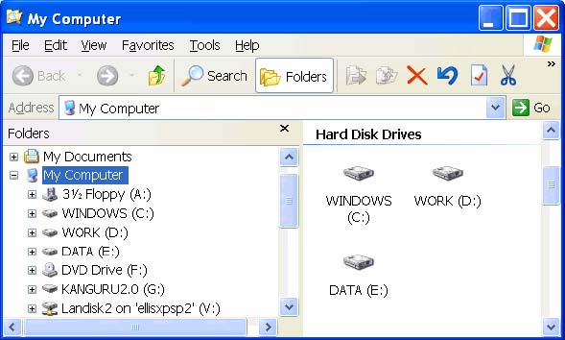

Section 5 Frequently Asked Questions

5.1 Meganet FAQs
1. Are there any public or private partitions on the VME BioDrive XD?
No. Currently, the VME BioDrive XD is not partitioned into public and private partitions. The VME BioDrive XD is accessible only by the Admin along with any additional user that the Admin may have enrolled. An unauthorized user will not be able to plug the device in and gain access to the device.

2. The VME BioDrive XD sometimes has difficulty obtaining a match. What can I do?
If your fingerprint sometimes has trouble obtaining a match, try repositioning your finger higher or lower on the sensor. If you are able to obtain a match, try enrolling the same finger a second time. Also, it is highly recommended that you enroll an alternate finger during setup.

3. Why doesn’t my computer detect my VME BioDrive XD on my USB port?
Verify that the Yellow LED on the VME BioDrive XD flashes momentarily when you insert the device into the USB extension cable. If the Yellow LED does not flash, connect the device directly to the computer's USB port to determine if the problem comes from the USB cable or hub that you may be using. Also, in Windows, you can check in the Device Manager to see if the VME BioDrive XD is recognized by the USB controller. If it is not recognized, make sure that the USB port is enabled in the BIOS. In rare cases, the computer may need to be rebooted when the VME BioDrive XD is connected for the first time. Reboot and try again.

5.2 Kanguru FAQs
1. Do I need to install anything on the PC to use the KanguruMicro Drive AES?
Yes, there is a small setup file that needs to be installed one time onto any PC that you wish to use the AES Drive on.

2. Do I need Administrator rights to use this drive?
Yes and no. Local administrator rights are required to install the setup file onto the PC. Once this is done, the flash drive can run under Local User mode. Many organizations also have software deployment tools, which can remotely install the necessary setup files throughout desktop clients as well, without having to setup on site.

3. Is any data left on the PC when I am done using the drive?
No, the only files left on the machine are program files. There is no actual usage data which is left behind. It is either stored in the encrypted area of the flash drive, or is “zeroed” (written over repeatedly by “0”s and “1”s to deleted any remnants while in a temporary cache).

4. Do I have to do anything to encrypt the data?
No, once you drag the data into the secure drive, it is 256-bit AES Encrypted.

5. What happens if I repeatedly enter an incorrect password?
After seven consecutive incorrect attempts, the data in the secure drive will be erased as a security precaution. There is a warning before this is done and the user has a final chance to enter the correct password.

6. Is there a minimum password requirement to ensure security?
Yes, the password requires a minimum of eight (8) characters with at least 1 upper case and 1 lower case alpha character in the password sequence.

Section 6 Web Links
- Office of Information and Technology Intranet Site (http://vaww.va.gov/oit/intranet/)
- Information Protection Site on the Information Assurance Web Portal (https://vaww.ocis.va.gov/portal/server.pt?open=512&objID=416&&PageID=292879&mode=2&in_hi_userid=2&cached=true)
- Kanguru Driver Version 1.5.5 Download (http://www.kanguru.com/tech_support/prod_tech.asp?prodid=71&r=usb)
- Meganet Web Site (www.meganet.com)

Section 7 References
- VA Directive 6504, Restrictions on Transmission, Transportation and Use of, and Access to, VA Data Outside VA Facilities
- VA Directive 6601, Removable Storage Media
- National Institute of Standards and Technology (NIST)
- Federal Information Processing Standards (FIPS) 140-2
Department of Veterans Affairs VA DIRECTIVE 6601
Washington, DC 20420 Transmittal Sheet
February 27, 2007

REMOVEABLE STORAGE MEDIA

1. REASON FOR ISSUE: To establish policy for The Department of Veterans Affairs (VA) removable storage media.

2. SUMMARY OF CONTENTS/MAJOR CHANGES: To implement information security requirements relating to removable storage media.

3. RESPONSIBLE OFFICE: The Office of Information and Technology (OI&T), 810 Vermont Avenue, NW, Washington, DC 20420, is responsible for the material contained in this directive.

4. RELATED HANDBOOK: None.

5. RESCISSION: None.

Certified By: BY DIRECTION OF THE SECRETARY
OF VETERANS AFFAIRS

Robert T. Howard Gordon H. Mansfield
Assistant Secretary for Deputy Secretary
Information and Technology

Distribution: Electronic

FEBRUARY 27, 2007 VA DIRECTIVE 6601

REMOVEABLE STORAGE MEDIA

1. PURPOSE AND SCOPE

a. This directive establishes Department of Veterans Affairs (VA) policy towards the uncontrolled use of all removable storage media, especially Universal Serial Bus (USB) devices, throughout the Department. The provisions of this directive are applicable VA-wide.

b. Information contained on such devices can be easily compromised if the device does not have adequate protective features. In addition, removable storage media, such as USB thumb drives, MP3 PLAYERS (e.g., iPods and Zunes, and external hard drives), can introduce malicious code to the VA network via USB ports, consequently their use must be better controlled.

c. The overall intent of this Directive is to limit the use of removable storage devices through USB ports to connect to VA information technology or access to VA sensitive information.

2. POLICY

a. All VA employees, contractors, business partners, and any person who has access to and stores VA information must have permission from a supervisor and Information Security Officer (ISO) to use such devices, and if used to store sensitive information, the device must contain protective features that have the approval of the local senior Office of Information and Technology (OI&T) official.

b. In addition, all Department staff, contractors, business partners, or any person who has access to and stores VA information must have written approval from their respective VA supervisor and ISO before sensitive information can be removed from VA facilities. VA sensitive information must be in a VA protected environment at all times, or it must be encrypted. OI&T must approve the protective conditions being employed.

c. Among USB devices, “thumb drives” clearly pose one of the highest data security risks. To further enhance the VA security posture, only USB thumb drives that are Federal Information Processing Standards (FIPS) 140-2 certified can be utilized. This requirement is applicable to all VA employees, contractors, business partners, or any person who has access to and stores VA information. Utilization of personally-owned USB thumb drives within the Department is prohibited. Transition to this posture must occur over the next sixty (60) days. The OI&T community, under the direction of the Chief Information Officer (CIO), will effect this transition.

d. FIPS 140-2 certified USB thumb drives will be procured with VA funding for VA employee utilization if the need to utilize a thumb drive as an external storage device

VA DIRECTIVE 6601 FEBRUARY 27, 2007

exists. This must be approved by the individual’s supervisor and must be provided by the local OI&T senior representative.

e. The procurement will be accomplished under the direction and control of OI&T.

f. VA employees are not authorized to access or store any VA information using a thumb drive that has not been procured by the VA.

g. Non-VA personnel (contractors, business partners, etc.) supporting VA must furnish their own FIPS 140-2 certified USB thumb drives that conform to the published listing of VA approved USB thumb drives. Further, permission must be obtained from a designated VA supervisor before they can be utilized.

h. The listing of VA approved USB thumb drives is derived from the National Institute of Standards and Technology (NIST) FIPS 140-2 Validation Lists for Cryptographic Modules. This listing can be found on the Information Assurance Web Portal, Technology Integration Security Services Web Site. The link to this portal and web site can be found on the VA Intranet, Office of Information and Technology home page.

3. RESPONSIBILITIES. All Under Secretaries, Assistant Secretaries, and Other Key Officials are responsible for the following:

a. Communicating this policy to all employees in their organizations and evaluating the security and privacy awareness activities of each organization in order to set clear expectations for compliance with security and privacy requirements and to allocate adequate resources to accomplish such compliance.

b. Developing mechanisms for communicating, on an ongoing basis, each workforce member’s role and responsibilities specific to data security and privacy policies and practices that will enhance our security and privacy culture.

4. DEFINITIONS

Thumb Drive: A USB Flash Drive is essentially NAND-type flash memory integrated with a USB 1.1 or 2.0 interface used as a small, lightweight, removable data storage device. This hot swappable, non-volatile, solid-state device is usually compatible with systems that support the USB version that the drive uses.

Sensitive Information: VA sensitive information is all Department data, on any storage media or in any form or format, which requires protection due to the risk of harm that could result from inadvertent or deliberate disclosure, alteration, or destruction of the information. The term includes information whose improper use or disclosure could

FEBRUARY 27, 2007 VA DIRECTIVE 6601

adversely affect the ability of an agency to accomplish its mission, proprietary information, records about individuals requiring protection under various confidentiality provisions such as the Privacy Act and the HIPAA Privacy Rule, and information that can be withheld under the Freedom of Information Act. Examples of VA sensitive information include the following: individually-identifiable medical, benefits, and personnel information; financial, budgetary, research, quality assurance, confidential commercial, critical infrastructure, investigatory, and law enforcement information; information that is confidential and privileged in litigation such as information protected by the deliberative process privilege, attorney work-product privilege, and the attorney-client privilege; and other information which, if released, could result in violation of law or harm or unfairness to any individual or group, or could adversely affect the national interest or the conduct of federal programs.

5. REFERENCES:

a. 40 U.S.C. Section 11101, Definitions

b. 44 U.S.C. Section 3544

c. VA Directive 6504, Restrictions on Transmission, Transportation, and Use of and Access to VA Data Outside VA Facilities.

d. 5 U.S.C. Section 552a

e. 45 C.F.R. Parts 160 and 164.

Department of Veterans Affairs
Memorandum

Date: <date signed>

From: <Requestor’s Title>

Subj: Request for Issuance of USB Flash Drive

To: Field Information Security Officer

Thru: <Requestor’s Immediate Supervisor>

- In order to accomplish my duties, I request a USB Flash Drive to store, transport and utilize VA information. My personal information follows:
<Requestor’s Full Name>
<Title>
<Home Address>
<City, State, Zip>
<Home Phone number>

- Justification for the use of this item (include what type of information will be most commonly stored on the drive):

- I require the following:

1 Gigabyte capacity – no further justification necessary

2 Gigabyte capacity – please justify this requirement below

- I acknowledge that if I plan to store, transport and utilize VA sensitive information outside a protected environment (as determined by OI&T staff), I must obtain approval from my local Director or his/her designee.

<requestor signature>

Required Concurrence and Approval

Approved / Disapprove

____________________________ _____________
<first name last name> Date
Immediate Superivsor

Concur / Do Not Concur

____________________________ _____________
<first name last name> Date
Information Security Officer

OI&T Region | Network | Station No. | Dept/Service | First Name | Last Name | Telephone No. | Email | Drive Size
1 | 21 | 612 | OI&T | Flash | Drive | (123) 456-9876 | flash.drive@va.gov | 1 Gigabyte

Department of Veterans Affairs
Memorandum

Date: <date signed>

From: <Requestor’s Title>

Subj: Authorization to transport and utilize VA sensitive information outside protected environments

To: Field Information Security Officer

Thru: <Requestor’s Service/Department Chief>

- In order to accomplish my duties, I require the capability to store, transport and utilize VA sensitive information outside protected environments, as defined by VA Directive 6504. VA information refers to all information, either electronic or paper-based. My personal information follows:
<Requestor’s Full Name>
<Title>
<Home Address>
<City, State, Zip>
<Home Phone number>

- Justification for the removal of VA sensitive information outside of protected environments (include where and how information will be used):

- The sensitive information, as defined in VA Directive 6504, I intend to store, transport and utilize includes (check all that apply):

Individually identifiable medical, benefits or personnel information
Information that can be withheld under the Freedom of Information Act
Financial information
Research information
Investigatory information
Commercial information
Quality assurance information
Law enforcement information
Information that is confidential or privileged in litigation
Information that could adversely affect the national interest or conduct of federal programs

- The timeframe I will store, transport and utilize VA sensitive information outside protected environments is:

30 days
180 days
One Year

- I acknowledge that the above statements are accurate and are in compliance with VA Directives 6601 and 6504, Removable Storage Media and Restrictions on Transmission, Transportation and Use of, and Access to, VA information outside protected environments.

- I acknowledge this document requires renewal upon expiration of the approval timeframe requested above.

<requestor signature>

Required Concurrence and Approval

Approved / Disapprove

____________________________ _____________
<first name last name> Date
Director or Designee

Concur / Do Not Concur

____________________________ _____________
<first name last name> Date
Information Security Officer

Concur / Do Not Concur

____________________________ _____________
<first name last name> Date
Facility Chief Information Officer

  Department of Veterans Affairs  Office of Information and Technology |  |  |  | INFORMATION TECHNOLOGY CHECK OUT SHEET  FOR GOVERNMENT FURNISHED EQUIPMENT (GFE)
EMPLOYEE NAME |  |  |  |  |  | ADMINISTRATION, STATION NUMBER & OFFICE |  |  |  |  | OFF-SITE USE OF VA DATA  WRITTEN AUTHORIZATION REQUIRED  YES NO
HOME PHONE | HOME ADDRESS |  |  |  |  |  |  |  |  |  | WILL SENSITIVE DATA BE USED?  YES NO
SELECT THE MOST APPROPRIATE CATEGORY BELOW:

Clinical Administrative/Management/Executive Law Enforcement OI&T Research Legal Counsel Other ____________________

DEVICE TYPE | VALUE |  | SERIAL NUMBER  EE NUMBER |  |  |  | SCHEDULED RETURN DATE  ACTUAL RETURN DATE |  |  | DESCRIPTION OF PROPERTY
LAPTOP
REMOVABLE MEDIA
BROADBAND CARD
MOBILE PHONE
PAGER
DESKTOP COMPUTER
OTHER (Specify)
GFE USAGE GUIDELINES
- Do not loan GFE to anyone.
- Do not install personal software.
- Save data only to secure locations, such as FIPS 140-2 compliant storage devices.
- Do not attach non-approved portable storage devices to this equipment.
- Secure and store GFE under lock and key when not in use.
- Do not check GFE as checked luggage when traveling.
- Do not modify the configuration of the GFE.
USER RESPONSIBILITIES
- I understand this equipment is provided for official use only.
- I understand the transit of VA Information off-site is strictly prohibited unless accompanied by express written authorization.
- I am required by my supervisor to utilize this equipment to perform the duties of my job.
- I accept responsibility for the equipment identified above issued to me by the Department of Veterans Affairs.
- I fully understand that I will be billed for the replacement cost for any damage or loss occurring as a result of negligence.
- I have read and understand VA Directives 6504 and 6601.
- I will care for and protect equipment from loss or damage and will notify IT staff of any damage or operational failures incurred.
- I understand that it is my responsibility to periodically return the equipment for routine maintenance.
EMPLOYEE SIGNATURE |  |  |  |  |  |  |  |  | DATE
FOR OI&T USE ONLY
FACILITY CIO  APPROVED DISAPPROVED |  |  |  |  |  |  |  |  | DATE EQUIPMENT ISSUED
SIGNATURE |  | PRINTED NAME |  |  |  |  |  |  | ISSUED BY (PLEASE PRINT NAME)

REFERENCE OPTIONAL FORM 7 – FPMR (41CFR) 101-20.110 9/98; VA Directive 6601 rev Mar-07

