Just in Time (JIT) requests for additional information Applicant steps
Just in Time (JIT) for VA Applicants - eRA Commons help: https://era.nih.gov/erahelp/Commons/default.htm#Commons/status/jit_VA.htm?TocPath=Status%2520Module%257CJust%2520in%2520Time%2520(JIT)%2520Search%2520for%2520SOs%257C_____2

- The eRA system sends a notification to the applicant that there is a Just in Time (JIT) request
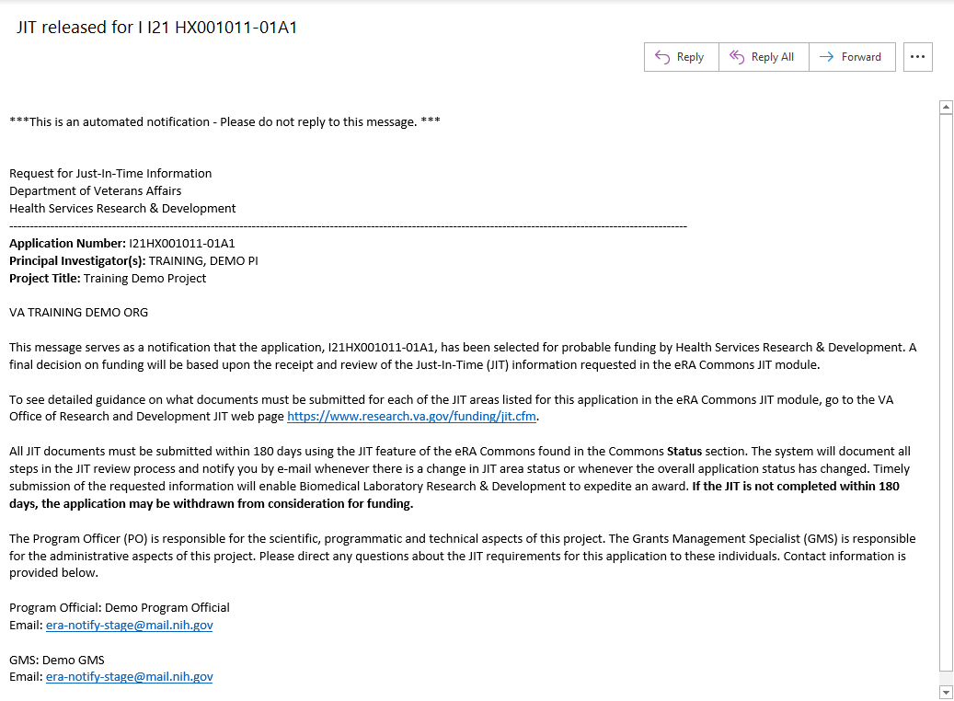
- Users with the PI or SO role will be able to view, add files, and save the JIT request through eRA Commons: https://public.era.nih.gov/commonsplus
  - Login to eRA Commons and search for application via Status
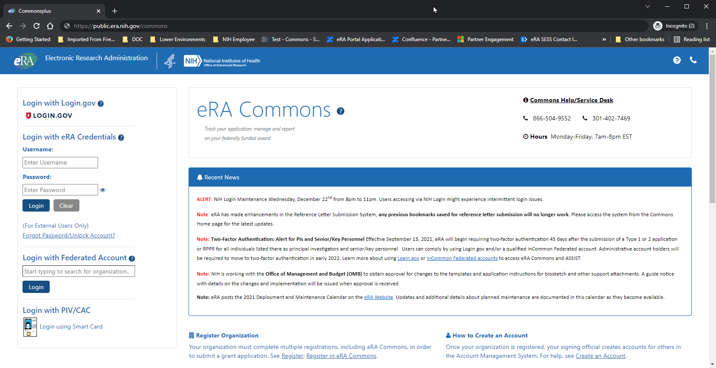
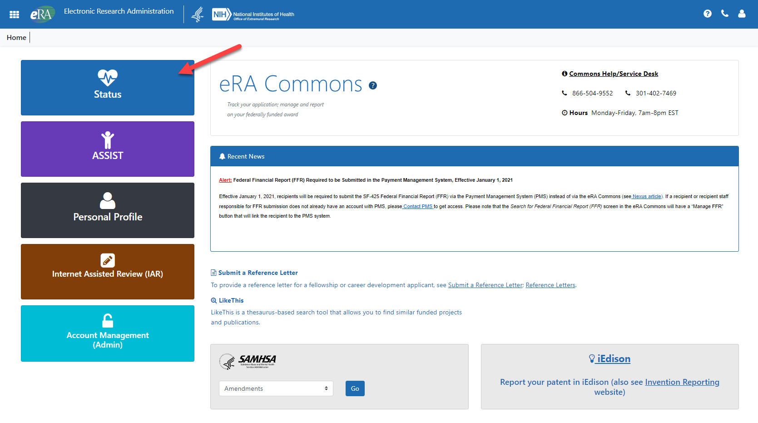
  - Users with the SO role – click on Just in Time link on Status page to get to the JIT Search page
  - Click on the ellipsis (also known as the kebab or three vertical dots) to the right of the application number, and then click on the JIT link to access the JIT request
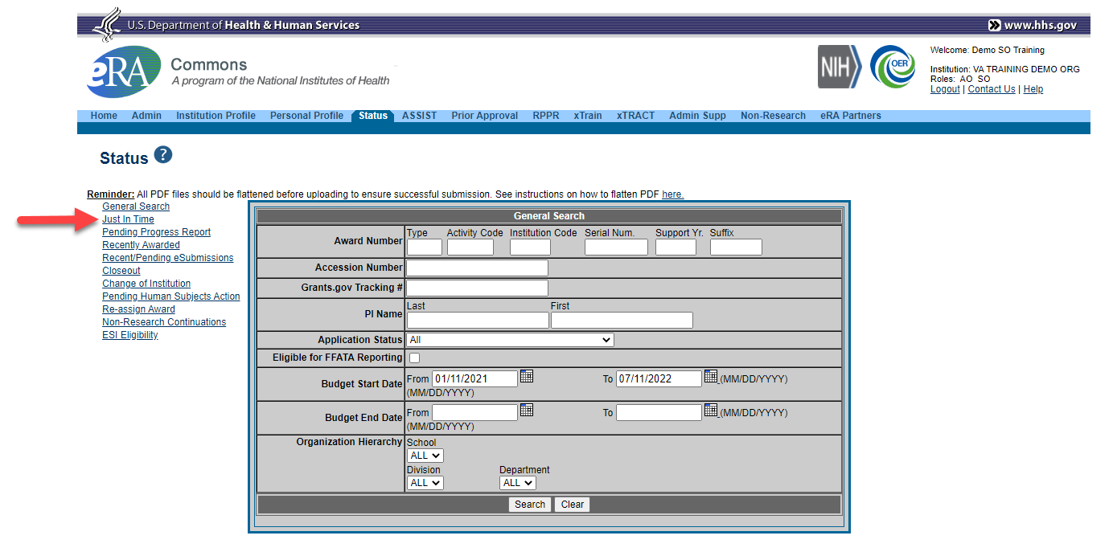
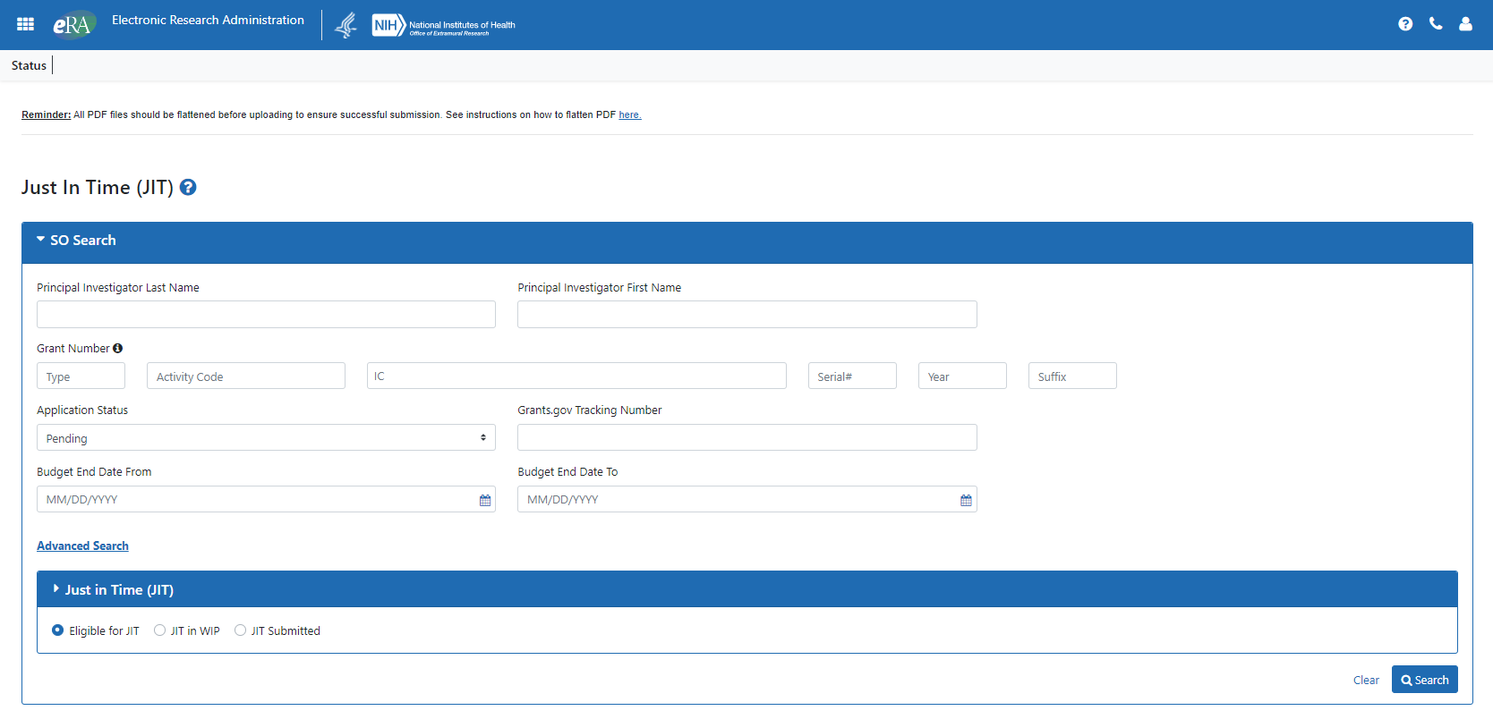
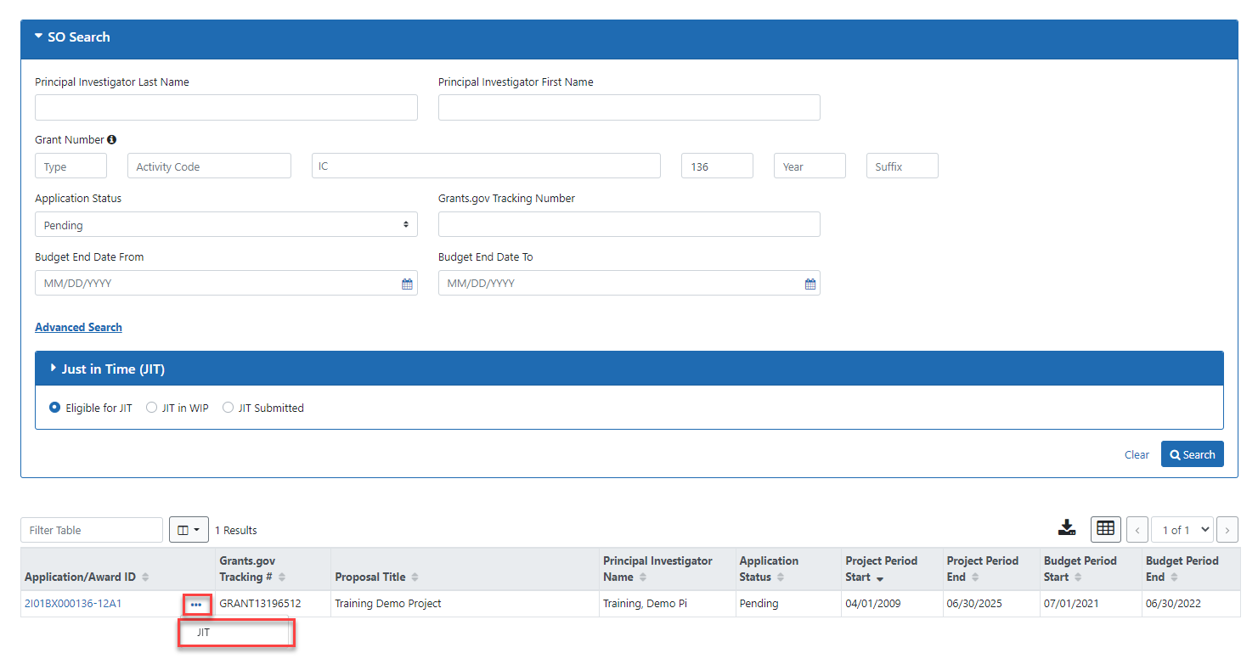
  - Users with the PI role – click on List of Applications/Grants option on Status page to view a list of applications/grants
  - Click on JIT in Available Actions to access JIT request
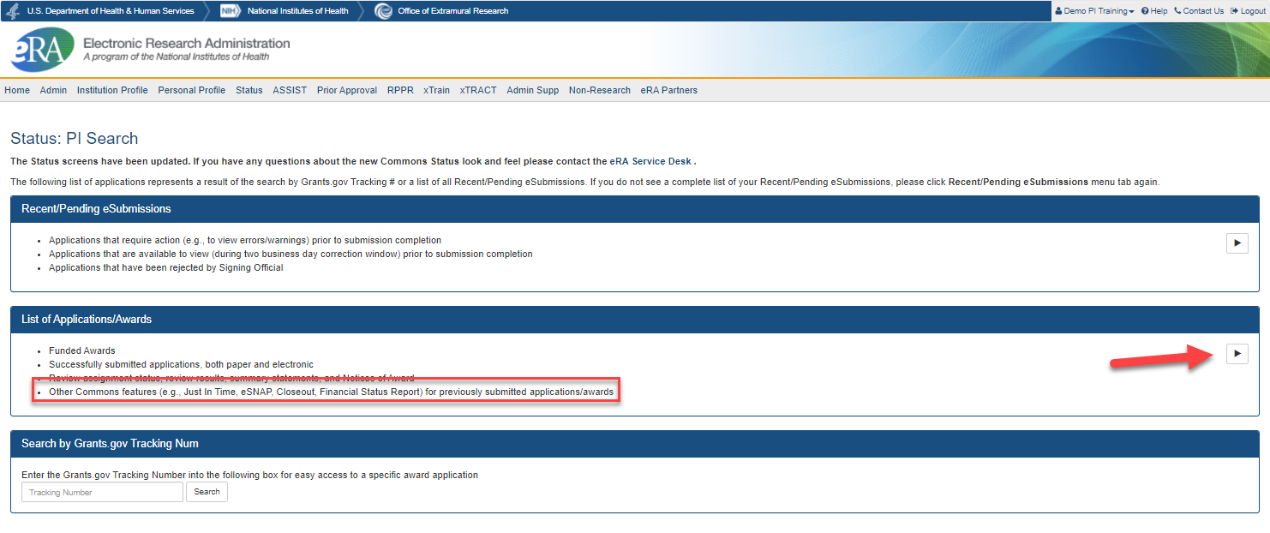
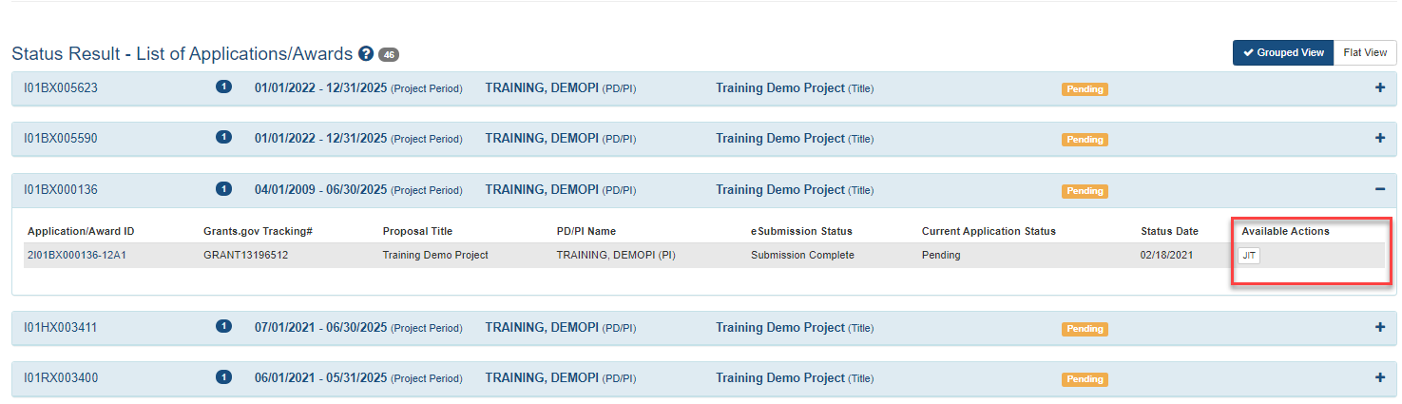
- View JIT request and upload documents for each section
  - Comments from VA entered by VA internal staff will be shown in the link Additional Agency Comments (The link will not appear if no comments were entered)
  - Documents uploaded by VA internal staff to share with the applicant will be shown in the link Agency Uploaded Files
  - Documents submitted by the applicant show in left side of section box
    - View file using link under Last Uploaded File Name label
      - If no submissions have been made, “None” will display under the label
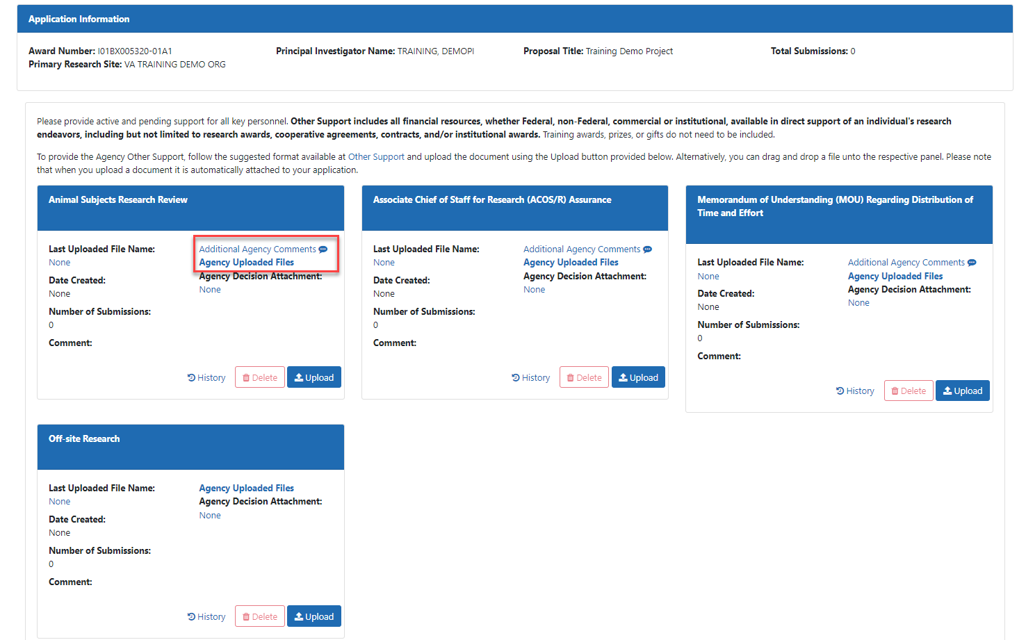
- Upload files for the appropriate section using the Upload button
  - Upload Principal Investigator Assurance and ACOS Assurance on behalf of additional sites
  - Only users with the PI role or the SO role can upload files
  - Click Save at the bottom of the page to save uploads
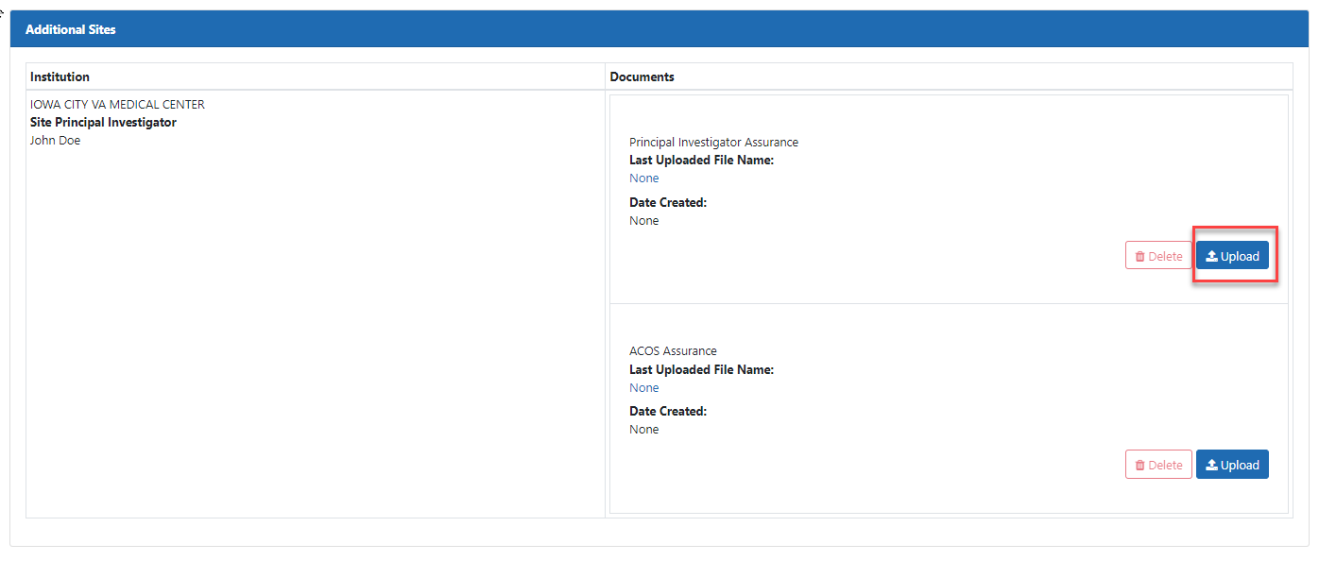

- Only users with the SO role will be able to submit the JIT to the agency
- The applicant submits documents in eRA Commons
  - The eRA system sends a notification to internal VA agency staff (and CVMO staff if the submission is for the Animal Subjects section)
  - Agency staff review submissions and approve or reject submissions in each section in eRA Commons
  - The eRA system sends a notification to the applicant if a section is approved or rejected
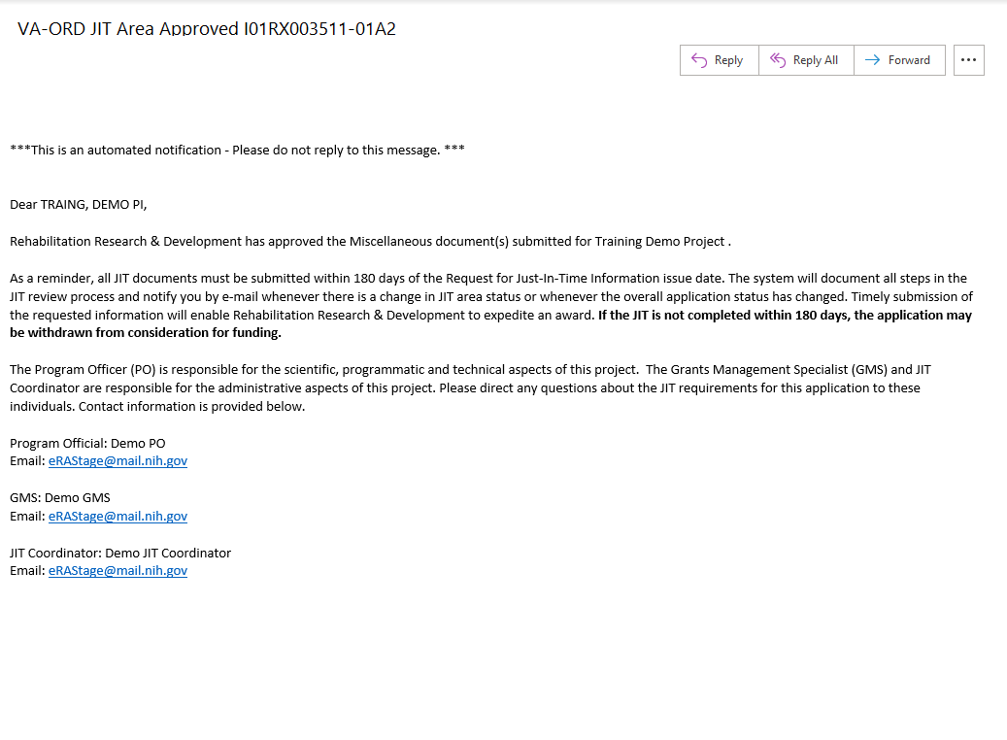
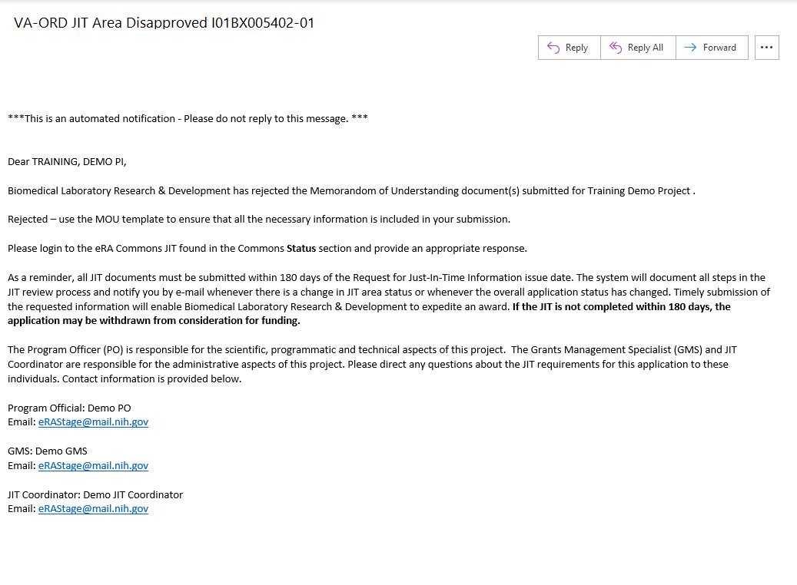
  - Documents added to the JIT request when VA agency staff Approved or Rejected the submission will be displayed in the link under the Agency Review File Name label
  - Comments added to the JIT request when VA agency staff Approved or Rejected the submission will be displayed under the “Comment” label
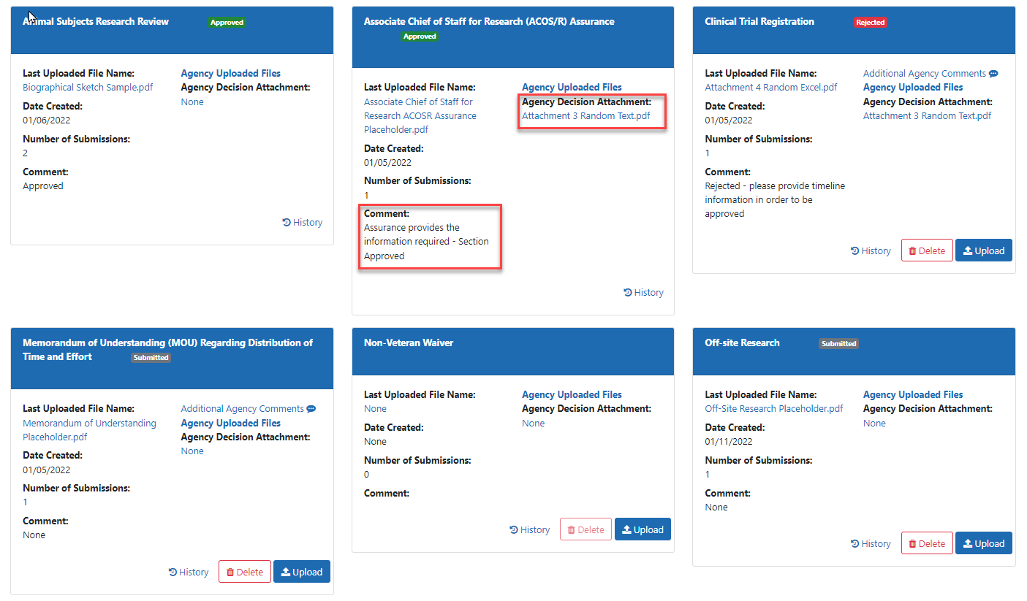
- Repeat Step 6 as needed
- View consolidated document in Commons by clicking on the application or grant number in the Status screen
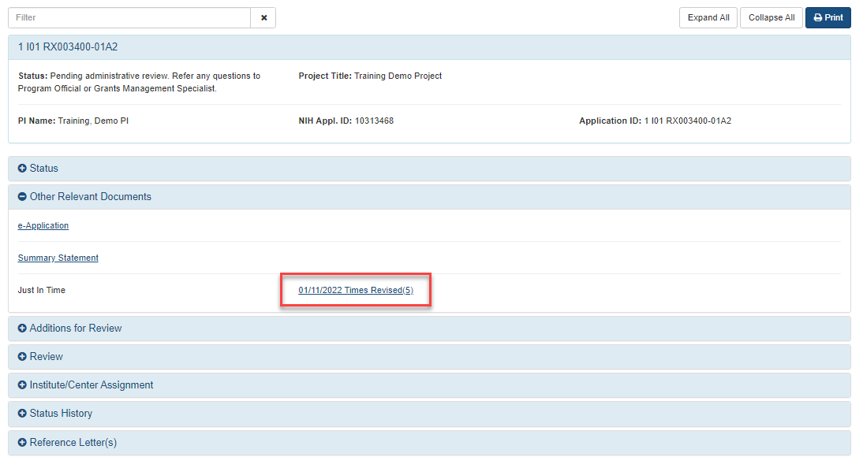
- A reminder notification will be sent after 90 and again after 150 days if any areas are not complete
Reminder after 90 days
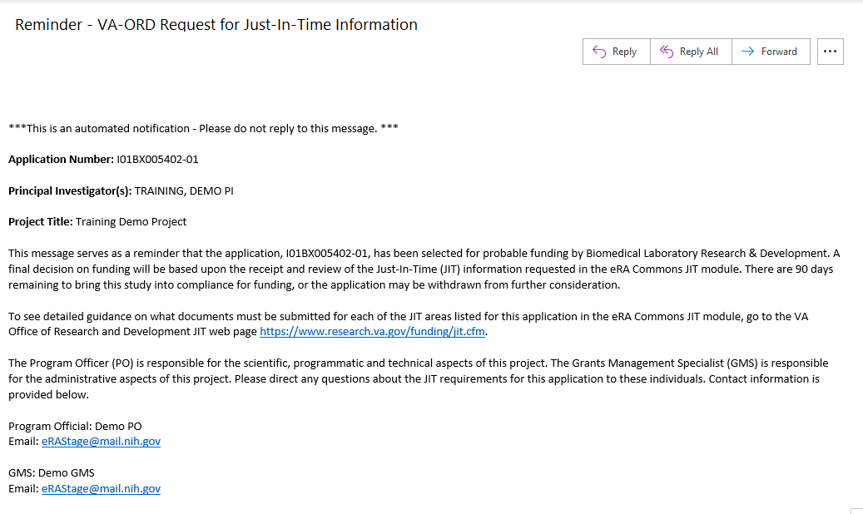
Final reminder after 150 days
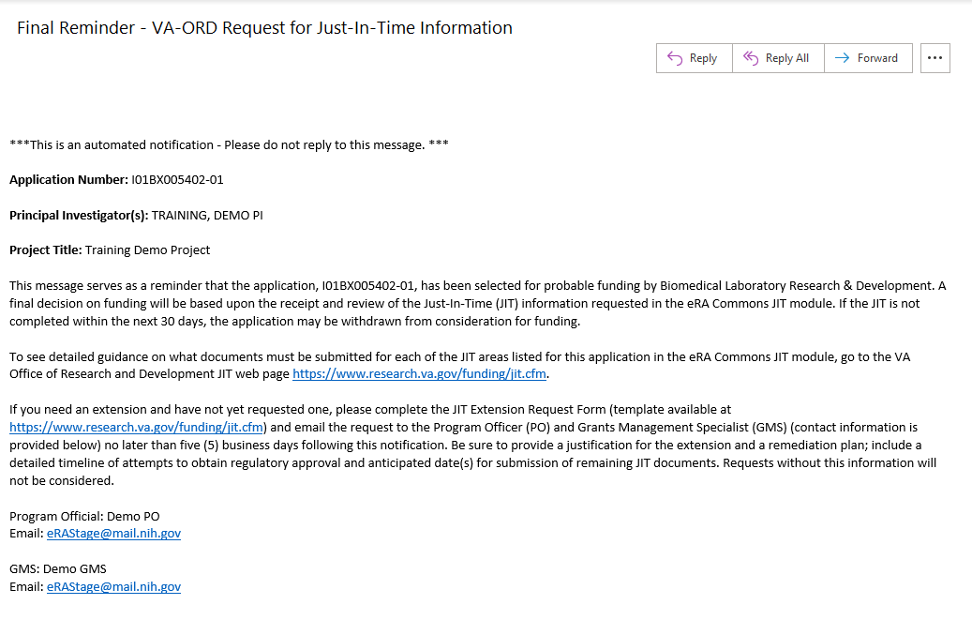
- VA agency staff give Overall Approval in eRA Commons – locking the JIT request and preventing further submissions
- The eRA system sends a notification to the applicant
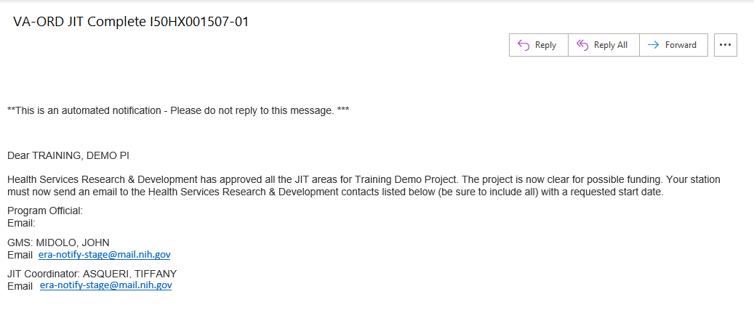
- NOTE: The JIT link on the Status page is removed once an application has been awarded but the consolidated document will continue to be available by clicking on the application or grant number in the Status screen

