VA SEMIANNUAL EVALUATION

of the

INSTITUTIONAL ANIMAL CARE AND USE

PROGRAM AND FACILITIES

Part 2 -- Table of Deficiencies and Departures

This form is for documenting the details about the observations noted in the checklists (Part 1, Sections A and B). Each deficiency, minor or significant, must be entered according to Instructions 2 and 3, below. Each “approved departure”, as defined by OLAW, must be entered according to Instruction 4, below. The IACUC may also document on this form, at its discretion, other observations that are not deficiencies, and details about “deviations” that are not “departures”, as defined by OLAW – these may be useful in addressing concerns raised by accreditation or regulatory agencies, or for monitoring purposes.

Instructions:

1) Enter identifying information in the header above:
Double click in the header area.
Then enter text after each “:”
(Note: The “Date of Last Semiannual Evaluation” is considered to be the date by which both the Review of the Program and the Inspection of the Facilities were last completed. Federal regulations require that a new evaluation be completed no later than 6 months after the last evaluation.)
Double click in the document area to return to the main body of Form 1.

2) Enter deficiencies with corrections that were still pending on the last report. Copy onto this form each item that was reported on Form 2 of the last semiannual evaluation, for which the correction was not yet completed when the last report was signed:
Enter the date the deficiency was first noted in a semiannual evaluation.
If the IACUC determines that a change in the scheduled date of correction is appropriate, strike out the previously approved date and add the new date below it.
Enter the actual date when the correction of the deficiency was completed. If the work is not yet complete, leave the “Actual date of completion” blank, but include in the description any relevant information about progress to date.

Note: USDA requires the IACUC to report any failure to adhere to the plan and schedule for correction that results in a significant deficiency remaining uncorrected beyond the correction date set by the IACUC. The report must be submitted in writing within 15 business days of missing the correction date set by the IACUC, through the IO, to the Animal and Plant Health Inspection Service (APHIS) and any Federal agency funding the activity involved. Therefore, for the IACUC to change the correction date of a significant deficiency, it must review the justification for the change and approve a new correction date at a convened committee meeting prior to the original correction date.

3) Enter each new deficiency noted on Form 1 (Checklist), Parts A and B, of this report:
The date the deficiency was first noted.
The Part (A or B) and Item # on Form 1 to which it applies.
When applicable, indicate the location where the deficiency was noted.
A description of the specific deficiency -- Include sufficient detail for an outside observer to recognize when it has been corrected), a description of any underlying programmatic or systemic conditions that may have led to the deficiency, and a description of the plans both for correcting the deficiency and for addressing underlying factors so as to prevent recurrence. [PHS (IV.B.3)] Be sure to include the name of the individual who will be responsible for overseeing progress on the corrective action, on behalf of the IACUC. (The table will expand to accommodate the text entered.)
The severity of the deficiency (Minor [M] or Significant [S]), as indicated on Form 1.
The scheduled date of correction – enter the date by which the IACUC has determined that the correction should be completed.
The actual date when the correction of the deficiency was completed (leave blank if the work is not yet complete.)

4) Enter each “departure” from PHS Policy, including the provisions of the Guide, that has been approved by the IACUC. [PHS (IV.B.3)]

For any deviation from a general standard described in the Guide, the following series of test questions may be applied to determine whether the deviation is considered a “departure” by OLAW:

1. Does the Guide describe the general standard as a “May” standard? If so, this deviation from the general standard is NOT a “departure”. Otherwise, for any “Should” or “Must” standard, proceed to the next question.

2. Does the Guide include an explicitly stated exception that allows for the deviation? If so, this deviation from the general standard is NOT a “departure. Otherwise, proceed to the next question.

3. Does the deviation meet a well-established performance standard for a “Should” standard, according to locally-defined and continuously monitored performance measures? If so, this deviation from the general standard is NOT a “departure”. Otherwise, it IS a “departure”, and may be approved by the IACUC only if justified on scientific, veterinary medical, or animal welfare grounds.

The test questions above are summarized in the following flow chart:
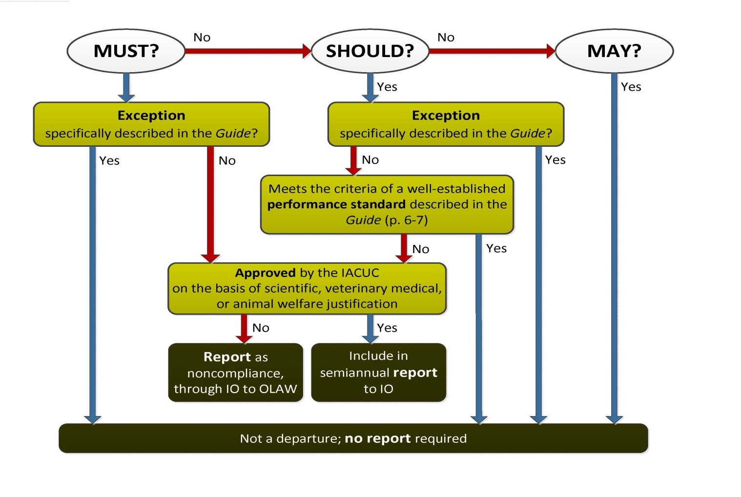

For approved departures that are documented in Appendix 9 of an IACUC-approved ACORP, simply attach a copy of Appendix 9. (The Official Date of Approval in the header must be included, but be sure to redact the name of the PI and the protocol number assigned by the IACUC.) Enter below the table here the total number of Appendix 9 pages attached.

For approved departures that are not documented in an Appendix 9, enter the information into this form as follows:
For “Original Date Noted”, enter the date of the IACUC meeting at which the departure was reviewed and approved.. [1200.07 (8.f(1)(d)2-3); PHS (IV.B.3) 9 CFR (2.31 (c )(3)); and Guide (p. 9]
If the departure relates to a specific item on Form 1, enter the Part (A or B) and Item # to which it applies.
If applicable, indicate the location to which the departure applies.
A description of the departure – include a summary of the grounds for granting approval for the departure.
Mark the “D” category, to indicate that the item details a departure.
Enter “N/A” in the columns for the “Scheduled Date of Correction” and the “Actual Date of Correction”.

5) Press “Tab” in bottom right cell to add rows to the table.

Original  Date Noted | Form 1 |  | Location | Descriptive Details | Category |  |  | Scheduled Date of Correction | Actual Date  Of Correction
 | Part | Item # |  |  | M | S | D
 |  |  |  | ►Person responsible for overseeing correction:
 |  |  |  | ►Person responsible for overseeing correction:
 |  |  |  | ►Person responsible for overseeing correction:
 |  |  |  | ►Person responsible for overseeing correction:
 |  |  |  | ►Person responsible for overseeing correction:
 |  |  |  | ►Person responsible for overseeing correction:
 |  |  |  | ►Person responsible for overseeing correction:
 |  |  |  | ►Person responsible for overseeing correction:
 |  |  |  | ►Person responsible for overseeing correction:
 |  |  |  | ►Person responsible for overseeing correction:
 |  |  |  | ►Person responsible for overseeing correction:

►Total number of Appendix 9 pages attached:

