IACUC Training Exercise #3- 2016
The following exercise may be useful in stimulating discussion regarding compliance with PHS Policy and VA Handbook 1200.07. To facilitate discussion, the first 3 pages of the exercise may be distributed to the IACUC members prior to a meeting. After a few minutes of discussion about the exercise during the meeting, the remaining pages of the exercise may be distributed to provide ideas for the committee’s consideration.

After OLAW published new guidance in 2015 about the qualifications required for the Non-Affiliated Member (NAM) and the Non-Scientific Member (NSM) on the IACUC, the Hometown VAMC IACUC carefully reviewed its own current membership and was relieved to find that the individuals assigned to the NAM and NSM roles do still meet the requirements for those roles. Because the IACUC members are acutely aware of how hard it can be, in a pinch, to find new members quickly who qualify for these roles, the committee agreed to line up some back-up members as soon as possible. Those who are identified will be invited to serve as appointed alternate members, so that they can become familiar with IACUC procedures, without committing to regular attendance, and without changing the number of members needed, to make quorum when the committee meets. Following are some of the candidates who were suggested. Decide for each, whether there is any reason that the person is disqualified from serving as the NAM, as the NSM, or as a member of the IACUC at all.

1. An RN, who never had anything to do with laboratory animals, and who wound up running the family restaurant for the past 25 years, without ever working in healthcare.

2. A bioethicist employed by Great Big University (GBU), which includes the Hometown VAMC animal facility as a satellite location of the GBU animal program, for the purposes of AAALAC accreditation. Has an undergraduate degree in philosophy, and a PhD in Bioethics. Has never worked with lab animals and is not on the IACUC at GBU.

3. The head librarian at the local public library, with an MS degree in Library and Information Science.

4. A physics professor at Another Nearby University (ANU). There happens to be another ANU faculty member who is currently collaborating with a Hometown VAMC investigator on an animal research project. The wife of the physics professor is a member of the IACUC at ANU.
5. A local plumber whose cousin is employed as an animal caretaker in the VMU at Hometown VAMC.

6. The pastor of a local church, who serves as the NSM on the IACUC of Small College, located down the street from Hometown VAMC, but with which no collaborative animal research involving Hometown VAMC is going on.

7. A lawyer specializing in animal research compliance, who asks to be compensated for time lost from work at the law firm, in order to be able to participate

8. The Research Compliance Officer at Hometown VAMC, who has never had any interest in science, and has an Associate’s Degree in management.

Use the NAM and NSM flow charts below to determine whether the descriptions of the candidates disqualify them from being appointed as the NAM, the NSM, or any IACUC member at all.

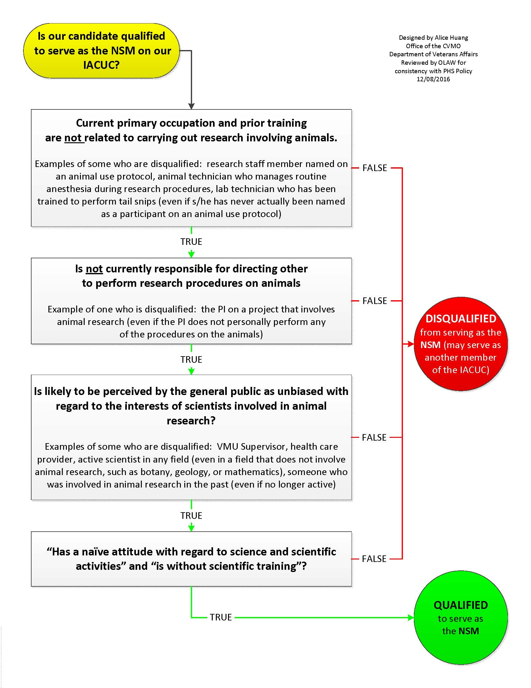
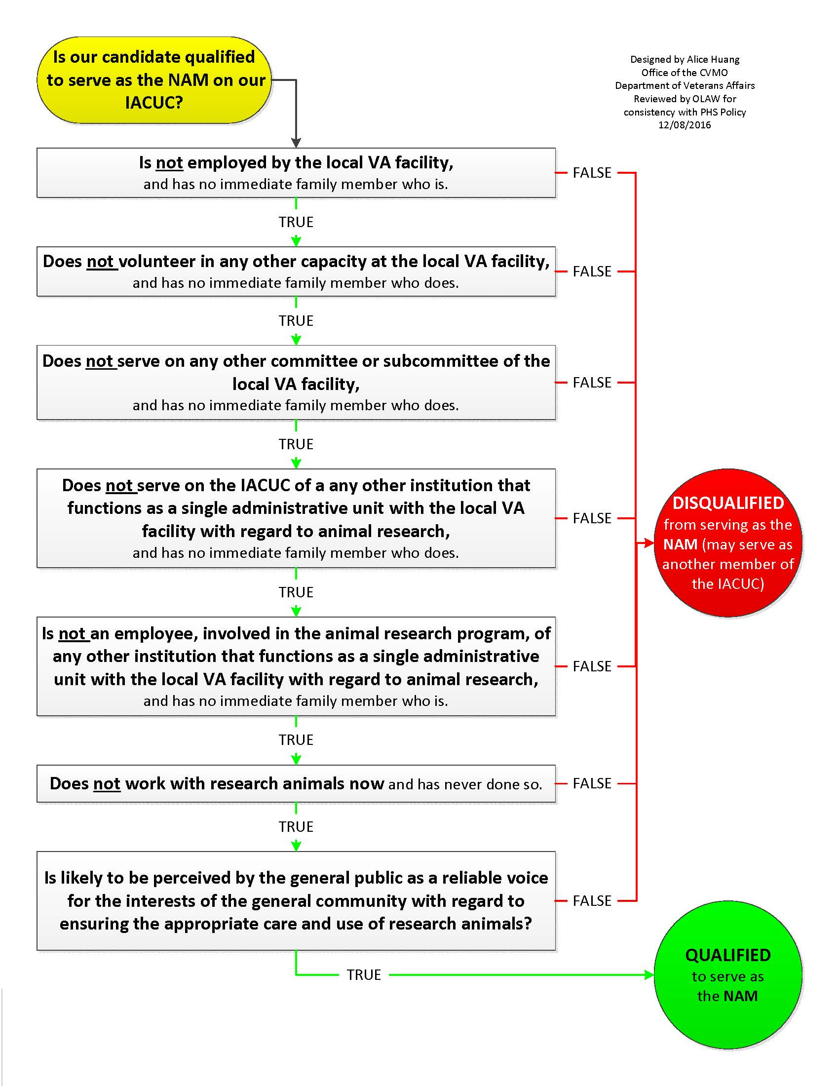
1. An RN, who never had anything to do with laboratory animals, and who wound up running the family restaurant for the past 25 years, without ever working in healthcare.

NAM – no problems
NSM – disqualified (training to earn RN means that this person cannot be considered “naïve” with regard to science)
IACUC membership – no problems

2. A bioethicist employed by Great Big University (GBU), which includes the Hometown VAMC animal facility as a satellite location of the GBU animal program, for the purposes of AAALAC accreditation. Has an undergraduate degree in philosophy, and a PhD in Bioethics. Has never worked with lab animals and is not on the IACUC at GBU.

NAM – no problems (Although GBU and Hometown VAMC function as a single administrative unit with regard to AAALAC Accreditation, the bioethicist does not have anything to do with the IACUC or otherwise with the animal research program at GBU)
NSM -- disqualified (training/experience with the scientific method that is part of the training for a PhD in Bioethics)
IACUC membership – no problems

3. The head librarian at the public library in town. Has a Master’s degree in Library and Information Science

NAM – no problems
NSM – no problems (Although the name of the degree includes the word “science”, this is just one of several designations used for the field of study, which is “understood to be concerned with recordable information and knowledge, and the services and technologies to facilitate their management and use. [This field] encompasses information and knowledge creation, communication, identification, selection, acquisition, organization and description, storage and retrieval, preservation, analysis, interpretation, evaluation, synthesis, dissemination, and management.” (Standards for Accreditation of Master’s Programs in Library and Information Studies, adopted by approval of the Council of the American Library Association, February 2, 2015, Committee on Accreditation of the American Library Association). As such, a person holding such a degree could be reasonably considered by the general public to have a “naïve attitude with regard to science and scientific activities”. OLAW recommends that, when there is potential for confusion about why a person is not disqualified from serving as the NSM, “the institution should maintain written documentation of the reason for the categorization”.
IACUC membership – no problems

4. A physics professor at Another Nearby University (ANU). There happens to be another ANU faculty member who is currently collaborating with a Hometown VAMC investigator on an animal research project. The wife of the physics professor is a member of the IACUC at ANU.

NAM – no problems (Although there is collaborative animal research between Hometown VAMC and ANU, and although a member of the physics professor’s immediate family is on the ANU IACUC, there is no reason given to think that the relationship between the Hometown VAMC and ANU is so close that they function as a single administrative unit with regard to animal research.)
NSM – disqualified (professional scientist)
IACUC membership – no problems
5. A local plumber whose cousin is employed as an animal caretaker in the VMU at Hometown VAMC.

NAM – no problems (A cousin is not considered a member of the immediate family)
NSM – no problems (There is no reason to think that the plumber has had formal training in science)
IACUC membership – no problems

6. The pastor of a local church, who serves as the NSM on the IACUC of Small College, which is located down the street from Hometown VAMC, but with which no collaborative animal research involving Hometown VAMC is going on.

NAM – no problems (There is no reason to think that Small College and Hometown VAMC function as a single administrative unit with regard to animal research.)
NSM – no problems
IACUC membership – no problems

7. A lawyer specializing in animal research compliance, who asks to be compensated for time lost from work at the law firm, in order to be able to participate

NAM – no problems (compensation does not add to income, only offsets loss due to time spent on IACUC matters)
NSM – no problems (expertise in animal use regulations does not correspond to expertise in the scientific method or scientific activities)
IACUC membership – no problems

8. The Research Compliance Officer at Hometown VAMC, who has never had any interest in science, and has an Associate’s Degree in management.

NAM – disqualified (employed by Hometown VAMC)
NSM – no problems
IACUC membership – disqualified (VHA Handbook 1058.01 bars RCO from membership on the IACUC).

Keep in mind that it is always prudent to examine each candidate’s circumstances as fully as possible. It is assumed in this exercise that there are no other reasons for disqualifying these candidates. For some candidates, the decision about whether they are qualified depends ultimately on a judgement of how they are likely to be perceived by the general public. For example, consider the plumber, candidate 5. The determination could become much more complicated as more details about the plumber emerge.

Is the plumber still qualified to serve as the NAM, if the cousin (or anyone else who is not an “immediate family member”) who works at Hometown VAMC, lives with the plumber’s family, and is regarded by the plumber as a regular member of the household? In that case, the plumber’s affiliation with Hometown VAMC would easily be perceived by the general public to be at least as close as it would be if the plumber’s adult child were the Hometown VAMC employee (even if the child no longer lives with her parents), and for the plumber to be viewed as potentially biased in favor of the interests of Hometown VAMC. It may not be appropriate to question every candidate in detail about the nature of each relationship, but it can be reasonable to ask about the employment of anyone whom the plumber considers to be a member of his household. Any information of this sort that comes to the attention of the Hometown VAMC IO would have to be carefully evaluated before a determination could be made as to whether the plumber is qualified to serve as the NAM.

Is the plumber still qualified to serve as the NSM, if he has always loved science, is an amateur astronomer, and contributes to several crowdsourced science projects on-line? More information might be needed before it can be determined whether the plumber meets the spirit of the requirements. If the plumber only enjoys stargazing in his backyard, and likes to contribute to scientific efforts even though he admits freely that he has no idea how science is actually carried out, this would probably not be a problem. If, on the other hand, the plumber has worked voluntarily with an astronomy professor at ANU and contributed enough to a project to have been included as a co-author on a paper published in a peer-reviewed journal, it might be hard to argue that the plumber has “a naïve attitude with regard to science and scientific activities”. It would be understandable for the general public to be skeptical that such a person could really be counted on to be unbiased with regard to the interests of scientists. Here again, this would have to be carefully evaluated before a determination could be made as to whether the plumber is qualified to serve as the NSM.

Although some candidates (as in several of the examples here) may qualify to serve as either the NSM or the NAM, and although there is no prohibition against having a single member serve both of these roles on the IACUC, it is best practice to include two separate members on the committee. In practical terms, it is simply easier to find a replacement if a member filling only one of these roles leaves the committee, so the risks of the committee being unconstituted for long are reduced by having the roles filled by separate members. In terms of the intent of the regulatory requirements, “to have a diversity of perspectives”, having a single member serve both roles diminishes the diversity of perspectives and the combined weight of those voices on the committee.

