Getting the Most Out of Insight Reports

Contents

Introduction 1

Accessing Insight Reports 1

Opening Insight Reports 2

Saving and Running Excel Macros 4

Saving the Macro: One-time Process 4

Step 1: Unhiding the Macro Folder 4

Step 2: Saving the Macro to your hard drive 5

Running the Macro 6

Step 3: Add the Developer Tab (if necessary) 6

# Introduction

IRBNet Insight Reports provide the end user with a detailed set of data extracts that give unique and timely views of operations at all VHA sites that are online in IRBNet. However, these reports can contain data that isn’t relevant to the user, and can be a bit difficult to read, so ORPP&E has developed a series of Microsoft Excel macros that reformat the reports into a more user friendly format.

# Accessing Insight Reports

Insight Reports are delivered via email at regular intervals, and cover a wide variety of data related to VHA research projects. IRBNet has created a guide (embedded below) that summarizes each of the reports they can provide. To receive these reports, IRB Net Support at gov[support@IRBNet.org](mailto:support@IRBNet.org) and let them know which reports you’d like delivered, and how often you’d like to receive them (daily, weekly, monthly, etc.).



# Opening Insight Reports

IRBNet Insight Reports are delivered as a zipped file; however for security purposes they are delivered in .zzz file format to your email. You will need to save the file in the .zip format before opening.

* In Outlook, select the dropdown menu next to the filename and click on “Save As”

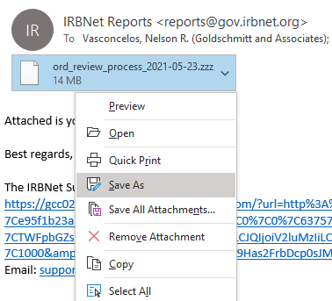

* Change the file extension from “.zzz” to “.zip”. In the “Save as Type” field, select the dropdown menu and choose “All Files.” See the two screenshots for the before and after.

Your file should now be saved as a .zip file; simply open the file to view the Excel files that contain the Insight Report data.

Back to Top

# Saving and Running Excel Macros

## Saving the Macro: One-time Process

**Steps 1 and 2 only need to be completed once.**

### Step 1: Unhiding the Macro Folder

1. Open File Explorer. It should be pinned to the bottom menu of your screen, and the icon looks like this: 
2. In File Explorer, navigate to the top menu and choose the **View** tab.
3. 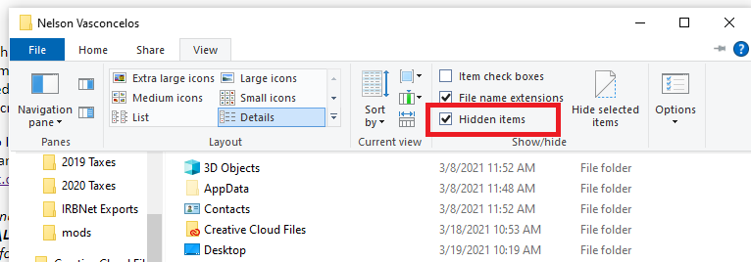Check the “**Hidden Items”** checkbox if it isn’t checked already, as in the below screenshot.

Back to Top

### Step 2: Saving the Macro to your hard drive

1. Navigate to the **C:\Users\[Your username]\AppData\Roaming\Microsoft\Excel\XLSTART** folder (see the below screenshot for an example of this file path)
2. 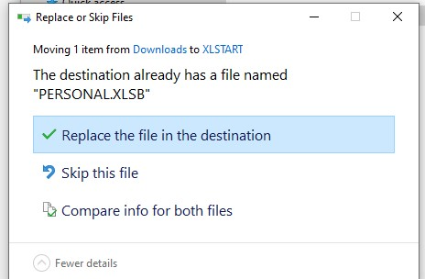Copy the provided PERSONAL.XLSB file (this is the file containing the macros). If you cannot see the folder, go back to step one and check the “Hidden items” box so that you can navigate to the folder. 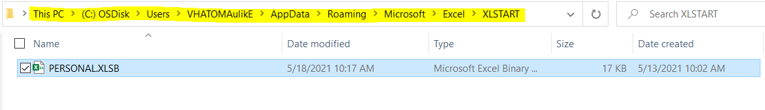If there is already a PERSONAL.xlsb file in this folder, you will see a prompt asking if you’d like to replace the file in the destination. Replace the file for the most updated macro file. PERSONAL.XLSB contains all the macros created to accompany the Insight Reports.
3. The PERSONAL.xlsb file will now run each time you open Excel, and you won’t need to repeat these steps again.

Back to Top

## Running the Macro

**Steps 3 and 4 need to be completed each time you would like to format the report, so that it is easier to read.**

### Step 3: Add the Developer Tab (if necessary)

If you already see the Developer ribbon in your version of Excel, you can skip to Step 4. It is located between the “View” and “Help” tabs on the top toolbar.

To turn on the Developer tab, execute the following steps (you should only need to do this once):

1. 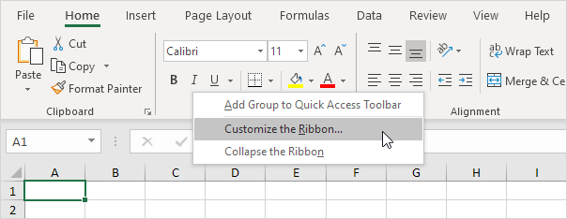Right click anywhere on the ribbon, and then click Customize the Ribbon.

Under Customize the Ribbon, on the right side of the dialog box, select Main tabs (if necessary), and check the Developer check box.

You should now see the Developer ribbon in your Excel menu bar.

Back to Top

### Step 4: Run the Macro

Once the Insight Report is open,

1. 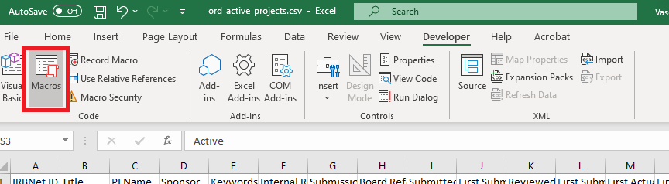Navigate to the Developer ribbon in Excel and choose Macros on the left. (See the below screenshot.) This will open the Macros dialog box.
2. 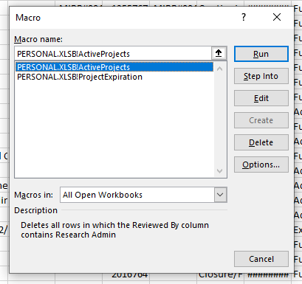Navigate to the macro whose name matches the Insight Report you are working with. For example, in the below screenshot the macro named **PERSONAL.XLSB!ActiveProjects** corresponds to the Active Projects Insight Report**.**  Select the applicable macro and click “Run” as seen in the below screenshot.

The Active Projects file should now be reformatted to exclude any unneeded rows or columns, add a column calculating the time between the First Submission Date and First Effective Date, and create a more visually pleasing, easier to read table, as seen in the below screenshot.

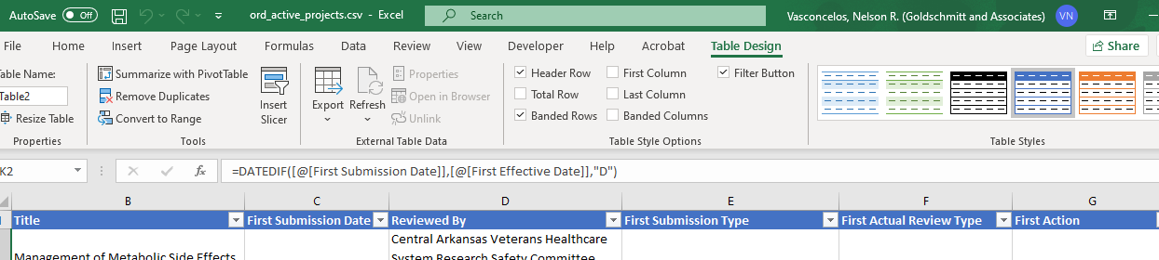

Your Insight Reports are ready to use. If you have any questions related to the macros, please contact Nelson Vasconcelos at [nelson.vasconcelos@va.gov](mailto:nelson.vasconcelos@va.gov). Direct questions about the reports to [govsupport@IRBNet.org](mailto:govsupport@IRBNet.org).

Back to Top