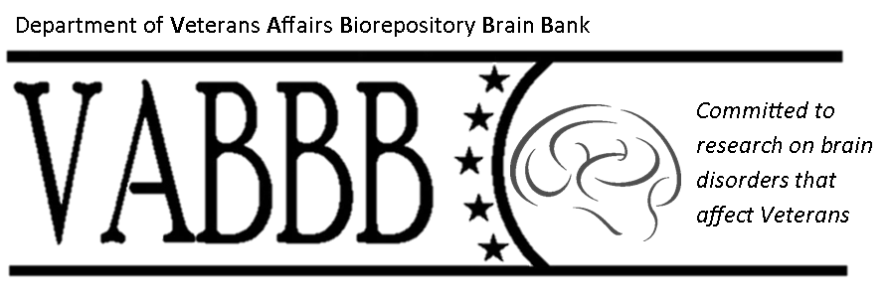

Gulf War Veterans’ Illnesses Biorepository Brain Bank
VA Boston Healthcare System
150 South Huntington Avenue
Boston, MA 02130

Permission to Contact for Research

Prospective Research Participant Name: _______________________________________

Below, please find a signed authorization for the VA Gulf War Veterans’ Biorepository Brain Bank Study to contact me regarding current and future research projects in which I may be eligible to participate. Please contact me by phone, mail, in-person, with information pertaining to the research in care of the following.

Contact person (if different from above): ____________________________________________

Telephone Number: _____________________________________________________________

Address: ______________________________________________________________________

Referred by (Addressee): ______________________________________________

Thank you.

Sincerely, For questions please call:
Neil Kowall, M.D 857-364-4198
Principal Investigator, GWVIB Brain Bank Toll free: 855-561-7827
Office Phone: 857-364-4831
Study Fax: 857-203-3074

I herewith authorize the addressee to release the contact information above to the office of the Gulf War Veterans’ Illnesses Brain Bank at the VA Boston Healthcare System, Jamaica Plain campus.

__________________________________________________ ________________________
Signature of Prospective Research Participant Date

