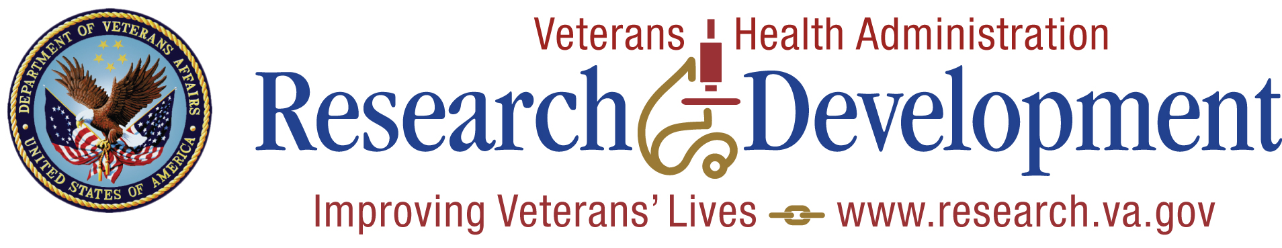

Sample Invitation Letter to Members of Congress

Date

The Honorable (full name of senator or representative)
United States (Senate/House of Representatives)
Washington, DC (20510 for Senate/20515 for House)

Dear Senator/Representative (last name):

In conjunction with National VA Research Week May 19-23, 2014, the (city) VA Medical Center will conduct a special Research Day on (date). We would be honored to have you as a speaker and would be grateful for the opportunity to share highlights of our research program with you. Our theme this year is “VA Research: Making a Difference.”

VA Research Week annually celebrates the achievements of VA researchers and the role they play in providing high quality care for Veterans and advancing medical science. It also serves to educate Veterans, the public, and the media about the research being conducted at our medical center, and its impact on treating and preventing disease and disability. Our program will begin at (time) and will feature (brief description of plans).

This event will be an excellent opportunity to learn about a program that benefits our nation's Veterans and the population at large. Other guests that are expected include (list prominent VA, VSO officials, etc.)

To confirm your attendance or to obtain additional information, please contact (name, title, phone number). I hope you and/or your designated staff member(s) will be able to join us as we celebrate 2014 National VA Research Week.

Sincerely,

VA Medical Center Director

